**CAMPUS RECRUITNMENT SYSTEM**

### A Project Work

### *Submitted in the partial fulfillment for the award of the degree of*

BACHELOR OF ENGINEERING

**CSE - IBM Big Data Analytics**

**Submitted by:**

**SHIV MURAT – 18BCS3768**

**NAVEEN -18BCS3775**

**BINAYAK-18BCS3795**

**Under the Supervision of:**

**Ms. Jothi Pruthi**



**DEPARTMENT OF COMPUTER SCIENCE AND ENGINEERING**

**APEX INSTITUE OF TECHNOLOGY**

### CHANDIGARH UNIVERSITY, GHARUAN, MOHALI – 140413,

**PUNJAB**

#### APRIL & 2018

**TABLE OF CONTENTS**

1. **DECLERATION**
2. **ABSTRACT**
3. **ACKNOWLEDGEMENT**

**INDEX**

1. **INTRODUCTION**
   1. **PROBLEM DEFINITION**
   2. **PROJECT OVERVIEW**
   3. **HARDWARE SPECIFICATIONS**
   4. **SOFTWARE SPECIFICATIONS**
      1. **HARDWARE SPECIFICATIONS**
      2. **SOFTWARE SPECIFICATIONS**
   5. **AIM**
   6. **EXISTING SYSTEM**
   7. **PROPOSED SYSTEM**
   8. **FEASIBILITY STUDY**
2. **LITERATURE REVIEW**

**2.1 LITERATURE REVIEW SUMMARY**

**2.2 LITERATURE REVIEW, FINDINGS, AND SURVEY**

**2.2.1 REVIEW**

**2.2.2 FINDINGS**

**2.2.3 LITERATURE SURVEY**

**3.SYSTEM ANALYSIS**

* 1. **USE CASE**
  2. **FUNCTIONAL REQUIREMENTS**
  3. **NON FUNCTIONAL REQUIREMENTS**
  4. **HARDWARE REQUIREMENTS**

1. **ANALYSIS MODELING** 
   1. **DATA MODELING**
   2. **ACTIVITY DIAGRAM**
   3. **FUNCTIONAL MODELING** 
      1. **LEVEL 0 DFD**
      2. **LEVEL 1 DFD**
   4. **TIMELINE CHART**
2. **DESIGN**

**5.1 ARCHITECTURAL DESIGN**

**5.2 FUTURE USER INTERFACE DESIGN**

* 1. **WATERFALL MODEL**

1. **IMPLEMENTATION**

**6.1 Technologies Used**

**6.2 Working of Project**

**6.2.1 EXECUTION CODE**

**6.2.2 ORIGINAL EXECUTION**

**SCREENSHOTS**

**6.3 Implementation Details**

**6.3.1 front end**

**6.3.2 Back End**

**6.4 Campus Placement prediction using Logistic**

**Regression**

**7.TESTING ABOVE IMPLEMENTATION**

**7.1 : UNIT TESTING**

**7.1.1 Introduction**

**7.1.2 Benifits**

**7.2 : INTEGRATION TESTING**

**7.2.1 Purpose**

**7.2.1.1 Big Bang**

**7.2.1.2 Top-down And Bottom-up**

**7.3 : SOFTWARE VERIFICATION AND VALIDATION**

**7.3.1 Introduction**

**7.3.2 Classification of Methods**

**7.3.3 Test Cases**

**7.4 : Black-Box Testing**

**7.4.1 Test Procedures**

**7.4.2 Test Cases**

**7.5 : White-Box Testing**

**7.5.1 Levels of tests in campus recruitment**

**7.5.2 Procedures**

**7.5.3 Advantages**

**7.5.4 Disadvantages and Limitations**

**7.6 DATA ANALYSIS**

**8. RESULT AND DISCUSSIONS**

**9. METHODOLOGY**

**9.1 Data gathering**

**9.2 Pre processing**

**9.2.1 Attribute selection**

**9.2.2 Cleaning missing values**

**9.2.3 Training and Test data**

**9.2.4 Feature Scaling**

**9.3 Processing**

**9.3.1 ID3 algorithm**

**9.3.2 Random forest**

**9.4 Random Forest Algorithm**

**9.4.1 ASSUMPTIONS FOR RANDOM FOREST**

**9.4.2 WHY WE USE IT ?**

**9.4.3 HOW ITS ALGORITHM WORKS ?**

**9.5 APPLICATIONS OF RANDOM FOREST**

**9.5.1 ADVANTAGES OF RANDOM FOREST**

**9.5.2 DISADVANTAGES OF RANDOM FOREST**

**10 PROCEDURE**

**11 CONCLUSIONS**

**12 FUTURE SCOPE**

DECLARATION

I, ‘Shiv Murat, Naveen, Binayak, student of ‘Bachelor of Engineering in computer Science’, session: 2018 – 2022 Department of Computer Science and Engineering, Apex Institute of Technology, Chandigarh University, Punjab, hereby declare that the work presented in this Project Work entitled **‘Campus Recruitment System’** is the outcome of our own bona fide work and is correct to the best of our knowledge and this work has been undertaken taking care of Engineering Ethics. It contains no material previously published or written by another person nor material which has been accepted for the award of any other degree or diploma of the university or other institute of higher learning, except where due acknowledgment has been made in the text.

#### 

ABSTRACT

Arrangement of understudies is one of the main targets of an instructive establishment. Notoriety and yearly confirmations of an organization perpetually rely upon the situations it gives it understudies. For that reason every one of the organizations, exhaustingly, endeavor to reinforce their situation office in order to work on their foundation in entirety. Any help with this specific region will emphatically affect a foundation's capacity to put its understudies. This will generally be useful to both the understudies, as well as the establishment. In this review, the goal is to investigate earlier year's understudy's information and use it to foresee the position opportunity of the ongoing understudies. This model is proposed with a calculation to anticipate something similar. Information relating to the review was gathered to structure a similar foundation for which the arrangement expectation is finished, and furthermore appropriate information pre-it was applied to handle strategies. This proposed model is likewise contrasted with other conventional order calculations, for example, Decision tree and Random woods concerning exactness, accuracy and review. From the outcomes acquired it is observed that the proposed calculation performs essentially better in examination with different calculations referenced.

Generally, now a day’s every college is conducting a placement drives to provide maximum employment for the students so conducting placement drives is not only necessary we need to make the reach of that drives to students. So this Campus Recruitment System application provides the solution. In this application the admin will the add the Coordinators, Co-coordinators are the persons who bring the placements to the college so when the coordinator gets logged into the application he can add the next coming drive details by giving Company Name, Departments to attend and the informatory videos and images. After adding the coordinator admin can upload the materials for students.

Students can know which type of question being asked and information about that placement. In this application, the drives which are going outside the college are not known to coordinators. So the students have an opportunity to add other placements. After adding other placements admin will see the other placements if the company is good he will not delete the details if the details are fake or company is not nice admin will delete the drive details.

**ACKNOWLEDGEMENT**

We have taken efforts in this project. However, it would not have been possible without the kind support and help of many individuals and organizations. I would like to extend my sincere thanks to Ms. Jyoti Pruthi, our project supervisor.

We are highly indebted to Apex Institute of Technology, Chandigarh University for their guidance and constant supervision as well as for providing necessary information regarding the project & also for their support in completing the project.

We would like to express our gratitude towards my parents & amp; members of AIT for their kind cooperation and encouragement which helped me in completion of this project. We would like to express our special gratitude and thanks to industry persons for giving us such attention and time.

Our thanks and appreciations also go to our colleague in developing the project and people who have willingly helped us out with their abilities.

1. **INTRODUCTION**

Nowadays we all are using the internet to do multiple things like booking, academic search, blogging, applying for any job, etc. This system can be used as an application to manage student information to related placement.

The system handles student as well as company data and efficiently displays all this data to respective sides. This System does all work regarding placement like collecting student records, Authenticate & activate the student profiles, Notifying eligible students via automated E-mail message, and Check the number and percentage of placed & unplaced students.

Proper login with time & role-based secured access is provided to Placement Officer, Company, College staff, and students. College staff can see the registered students and their status. Since the automated system is demanded now-a-days, educational infrastructures like colleges needed their manual system to function on computersystems.

One of such system which is of major importance is placement automation for campus recruitment. This project is aimed at developing a web application for the Placement Department of the college. This system can be used as an application for the Placement Officer of the college to manage the student information with regards to placement.

Students logging should be able to upload their information in the form of a resume. So, all the information will store the details of the students including their background information, educational qualification, personal details, and all the information related to their resume.

This system helps Company to access the student information with regards to placement. Computer based information system are designed to improve existing system. Company can notify the students about the recruitment online via sending e-mail..

# Problem Definition

A college Campus Recruitment System that consists of a student login, company login and an admin login. The project is beneficial for college students, various companies visiting the campus for recruitment and even the college placement officer. The software system allows the students to create their profiles and upload all their details including their marks onto the system. The admin can check each student details and can remove faulty accounts.

The system also consists of a company login where various companies visiting the college can view a list of students in that college and also their respective resumes. The software system allows students to view a list of companies who have posted for vacancy. The admin has overall rights over the system and can moderate and delete any details not pertaining to college placement rules. The system handles student as well as company data and efficiently displays all this data to respective sides.

* 1. **Project Overview**

A college campus recruitment system that consists of a student login, company login and an admin login. The project is beneficial for college students, various companies visiting the campus for recruitment and even the college placement officer. The software system allows the students to create their profiles and upload all their details including their marks onto the system.

The admin can check each student details and can remove faulty accounts. The system also consists of a company login where various companies visiting the college can view a list of students in that college and also their respective resumes.

The software system allows students to view a list of companies who have posted for vacancy. The admin has overall rights over the system and can moderate and delete any details not pertaining to college placement rules. The system handles student as well as company data and efficiently displays all this data to respective sides.

**1.3 Hardware Specification**

This involves questions such as whether the technology needed for the system exists, how difficult it will be to build, and whether the firm has enough experience using that technology. The assessment is based on outline design of system requirements in terms of input, processes, output, fields, programs and procedures.

This can be qualified in terms of volume of data, trends, frequency of updating inorder to give an introduction to the technical system. The application is the fact that it has been developed on windows XP platform and a high configuration of 1GB RAM on Intel Pentium Dual core processor. This is technically feasible .

The technical feasibility assessment is focused on gaining an understanding of the present technical resources of the organization and their applicability to the expected needs of the proposed system. It is an evaluation of the hardware and software and how it meets the need of the proposed system.

**1.4 Software Specification**

Brackets project: Brackets is a text editor that can be used for web development & application based projects. It is designed to help for us developers and designers in coding CSS, HTML, and Javascript easier and faster.

* PROGRAMMING LANGUAGES: HTML, CSS, JAVASCRIPT

This section includes the Software and hardware requirements for the smooth running of the application::

**1.4.1 Hardware Requirements**

|  |  |
| --- | --- |
| **Number** | **Description** |
| 1 | PC with 250 GB or more Hard disk. |
| 2 | PC with 2 GB RAM. |
| 3 | PC with Pentium 1 and Above. |

**1.4.2 Software Requirements**

|  |  |  |
| --- | --- | --- |
| **Number** | **Description** | **Type** |
| 1 | Operating System | Windows XP / Windows |
| 2 | Language | PHP |
| 3 | Database | MySQL |
| 4 | IDE | Visual Code |
| 5 | Browser | Google Chrome |

**1.5 AIM**

The major aim of campus placement is to identify the talented and qualified professionals before they complete their education. It provide employment opportunities to students who are pursuing or in the final stage of completing the course. This process reduces the time for an industry to pick the candidates according to their need.It is a cumbersome activity and hence majority of the companies find it difficult to trace the right talent.

Many students do not understand the importance of placement training that is being imparted, whether it is an aptitude training or soft skills. They show the least interest in this due to various factors viz., projects, assignments or more of activities loaded by the colleges as part of their curriculum thinking that it is not useful. It is the responsibility of the companies training on placement to make the students equipped on all aspects of career development along with creating a very good impact in them which makes them feel every minute they spend in the placement training session is worth being there and will help them in getting placed in their dream companies.

**1.6 EXISTING SYSTEM**

All processes in existing system are handled manually. All the work that is done in the existing system is done by the human intervention .As all the work is done manually, there were a lot of workload on placement officer and it also increases the maximum chances of errors.

This is so slow and time consuming. Due to increase in number of user’s the process become more difficult.In the system. This big problem is the searching; sorting and updating of the student data and no any notification method available for giving information to student except the notice board.

**1.7 PROPOSED SYSTEM**

The proposed Online Placement system is intended to avoid all the drawbacks of existing system. It will add some more features than the existing system.

The proposed Online Placement system is a cost effective way of doing the manual processes done in the existing system. This helps the organization to win the war in the existing competitive world.

**1.8 FEASIBILITY STUDY**

A feasibility study is a high-level capsule version of the entire System analysis and Design Process. The study begins by classifying the problem definition. Feasibility is to determine if it’s worth doing. Once an acceptance problem definition has been generated, the analyst develops a logical model of the system. A search for alternatives is analyzed carefully. There are 3 parts in feasibility study::

1. **Operational Feasibility**

Operational feasibility is the measure of how well a proposed system solves the problems, and takes advantage of the opportunities identified during scope definition and how it satisfies the requirements identified in the requirements analysis phase of system development.The operational feasibility assessment focuses on the degree to which the proposed development projects fits in with the existing business environment and objectives with regard to development schedule, delivery date, corporate culture and existing business processes.To ensure success, desired operational outcomes must be imparted during design and development. These include such design-dependent parameters as reliability, maintainability, supportability, usability, producibility, disposability, sustainability, affordability and others. These parameters are required to be considered at the early stages of design if desired operational behaviours are to be realised. A system design and development requires appropriate and timely application of engineering and management efforts to meet the previously mentioned parameters. A system may serve its intended purpose most effectively when its technical and operating characteristics are engineered into the design. Therefore, operational feasibility is a critical aspect of systems engineering that needs to be an integral part of the early design phases.

1. **Technical Feasibility**

This involves questions such as whether the technology needed for the system exists, how difficult it will be to build, and whether the firm has enough experience using that technology. The assessment is based on outline design of system requirements in terms of input, processes, output, fields, programs and procedures. This can be qualified in terms of volume of data, trends, frequency of updating inorder to give an introduction to the technical system. The application is the fact that it has been developed on windows XP platform and a high configuration of 1GB RAM on Intel Pentium Dual core processor. This is technically feasible .The technical feasibility assessment is focused on gaining an understanding of the present technical resources of the organization and their applicability to the expected needs of the proposed system. It is an evaluation of the hardware and software and how it meets the need of the proposed system.

1. **Economical Feasibility**

Establishing the cost-effectiveness of the proposed system i.e. if the benefits do not outweigh the costs then it is not worth going ahead. In the fast paced world today there is a great need of online social networking facilities. Thus the benefits of this project in the current scenario make it economically feasible. The purpose of the economic feasibility assessment is to determine the positive economic benefits to the organization that the proposed system will provide. It includes quantification and identification of all the benefits expected. This assessment typically involves a cost/benefits analysis.

1. **LITERATURE REVIEW**



**1]campus employment information network development based on android platform by cai zhongxi in 2015.**

In this paper, system development have no greater difficulty. SQLite offers structured data store and at the same time ,the amount of the resource is very low so they need less memory space and processing speed has very fast. Development of mobile communication technology, mobile phone transmission is more faster based on more powerful information Processing Extensible ability as well as 3G high speed Data Transmission. This application are written in powerful PYTHON language and it is also support the another language like C.

**2]Campus Recruitment Management: Platform based on dynamic electronic commerce by Diksha Varshney, Bhumika Sharma, Somya Jain in 2014**

In this paper the electronic recruitment systems are used to facilitate and improve human resource management. They address the needs of employers and job-seekers via internetworking means which increase the speed of employment, and improve the quality of recruitment and services.

**3]Information System Based On College Campus by Shilpa Bilawane, Pranali Jambhulkar in 2015**

In this paper have webpages is used to provide information regarding there college and Android is the fastest growing open source mobile device platform, which in turn is powered by Linux operating system. Webpage offers a simple yet powerful application development framework and also open access to APIs to build richer mobile applications

**4]Web Based Placement Management System by Anjali, Jeyalakshmi, Anbubala. R, Sri Mathura Devi. G, Ranjini. V in 2016**

In this paper have the development of the system is improved facilities. The system can overcome all the limitation of the existing system, such as student’s information is maintained in the database, it also gives more security to data, ensures data accuracy as well as reduces paper work and save time, only eligible students get chance, it makes information flow efficient and paves way for easy report generation, reduce the space And system is cost effective.

* 1. **Literature Review Summary**

Campus recruitment is considered to be a significant factor for both the educational institutions and corporate. The literatures investigated show that there is a mismatch that exist between the students skills and the industry expectations. There are various factors that influence a student to attract him or her for a job offered by a company. More than the technical skills and the subject knowledge, it is the soft sill which is given more weightage during the campus recruitment

process. The industry in order to get good talent from the campuses should engage themselves with the campuses through internships, curriculum development, student workshops etc.

The studies emphasize the characteristics of campus recruitment process. The decision of engineering students in making their first career choice depends mostly on intrinsic reasons rather than extrinsic reasons (Gokuladas, 2010). In India, the software services companies are the major campus recruiters. They recruit from all engineering branches with a perception that a student with logical and problem - solving ability may be able to do well in this industry. The study conducted reveal that the companies have to build their image on the campuses to attract good talent.

The brand image of the company is considered as a prime influencing dimension by the non - computer science / IT students in making their career choice when they have an option of choosing among multiple

companies.

Bruce Basta, D’ Archy Becker, P.Jane Staly, Richard S Sathe and Kate Mooney (2007), through their study have opined that the campus recruitment process should be not considered as a onetime recruitment process. It should be considered as an ongoing process. The corporate instead of visiting all the campuses, should identify some reputed campuses and brand themselves. If there are not much recruitments happening during an year, the corporate should engage the identified campuses through branding activities like Guest lectures, student workshops, sponsorships etc.

The objective of the study is to analyse the perceptions of the students and the HR managers with regard to the two of the important parameters in campus recruitment process namely,

(a) campus recruitment season

(b) campus hiring salary.

HI: The opinion of HR managers and students is same with respect to campus recruitment season.

H2: The opinion of the HR managers and students in expectations on campus hiring salaries is same.

HI: The opinion of HR managers and students is same with respect to campus recruitment season.

H2: The opinion of the HR managers and students in expectations on campus hiring salaries is same.

HI: The opinion of HR managers and students is same with respect to campus recruitment season.

H2: The opinion of the HR managers and students in expectations on campus hiring salaries is same.

* 1. **LITERATURE REVIEW , FINDINGS and SURVEY**
     1. **REVIEW**



There has been always confusion between the industry and the educational institutions in finding out the right season for the campus placements. Industry through the NASSCOM and other regulatory bodies has been changing the recruitment season between July and January.

There has been no consistency from the industry on the recruitment season. The students feel that June and July would be very early as they would not be prepared for the interviews. October and November months are examination months and after January, they are engaged with their project work and hence these months are less preferred.

Most of the companies freeze on their campus recruitment budgets by June / July and hence the HR managers feel that after July will be an ideal period for the recruitments. The months between August and September were perceived to be the ideal months for recruitment by both the recruitment managers and the students.

**2.2.2 FINDINGS**



Based on the above findings, the employers should frame a recruitment calendar which suits the students. This also would enable the recruitment managers to do branding engagements on campus to create the awareness among the students.

Proper planning of recruitment schedule would help the recruitment managers to plan for the joining of the recruited students and also offer them internships / project work during their final semester. There has always been a mismatch in the salary expectations of the entry level graduates, which were highlighted by the earlier studies.

Though the salary levels in the IT services sector in India for the campus recruits has not changed for more than 5 years, the attractiveness of employment in IT sector has not decreased. Since the supply of graduates for the IT sector has increased substantially over the years, the industry has not increased the entry level salaries. The entry level salary expectations of the students have increased due to the rise in the cost of education.

**2.2.3 LITERATURE SURVEY**

Earlier recruitment was done manually and it was all at a time consuming work. Now it is all possible in a fraction of second. It is all done online without much time consuming. Today's recruitment applications are designed to do a whole lot more than just reduce paperwork. They can make a signi cant contribution to a company's marketing and sales activity. Recruitment websites and software make possible for managers to access information that is crucial to managing their sta , which they can use for promotion decisions, payroll considerations and succession planning.Campus Recruitment Website provides online help to the users all over the world. Using web recruitment systems like recruitment websites or jobsites also play a role in simplifying the recruitment process. Such websites have facilities where prospective candidaes can upload their CV's and apply for jobs suited to them. Such sites also make it possible for recuiters and companies to post their sta requirements and view pro les of interested candidates[1].

Recruitment is done manually. These tasks are time consuming. It may take one month or long. People around the world cannot apply. Online Recruitment system very convenient because in the manual system there are lot of di culties in conducting and managing a recruitment exam, short listing, maintaining sta etc. Campus Management system (CRS) project which relates to HRMS department will maintain entire recruitment service and provide services for job vacancies. This website allows companies to post job vacancies with respect to the subject on which they are looking for employs and job seekers need to log in to their account with given login and password and check job vacancies[2]. Job seekers can check there job application status from their account. This project will provide scope for future development[3].

PHP supports a large number of major protocols such as POP3, IMAP, and LDAP. PHP4 added support for Java and distributed object architectures (COM and CORBA), making ntier development a possibility for the rst time. PHP performs system functions, i.e. from les on a system it can create, open, read, write, and close them.

The other uses of PHP are: PHP can handle forms, i.e. gather data from les, save data to a le, thru email you can send data, return data to the user. You add, delete and modify elements within your 5 database thru PHP. Access cookies variables and set cookies.Using PHP, you can restrict users to access some pages of your website.It can encrypt data. In order to develop and run PHP Web pages, three vital components need to be installed on your computer system.

**Web Server** - PHP will work with virtually all Web Server software, including Microsoft's Internet Information Server (IIS) but then most often used is freely available Apache Server.

**Database** - PHP will work with virtually all database software, including Oracle and Sybase but most commonly used is freely available MySQL database.

**PHP Parser** - In order to process PHP script instructions, a parser must be installed to generate HTML output that can be sent to the Web Browser. •

# SYSTEM ANALYSIS

# Use Case

# 

Description: In this use-case, shown in Figure 3.1, there are three actors- Admin, Company, Student. Admin will be able to Login to system, send noti cations, Manage students, reply queries, manage company details, View student details. Student will be able to post queries, manage pro le, view company details. Company will be able to post vacancies and post eligibility criteria.

* 1. **Functional Requirements**

• Administrator should have access to all details of the system.

• Administrator will train the system and generate rules-set.

• User can register into the system.

• User can login into system any time and give input to system.

**3.3 Non Functional Requirements**

• The system should provide the accurate estimated output to the user. The system should be able to increase the e ciency and performance of prediction results.

• The system should allow user to access information in anywhere with anytime.

**3.4 HardwareRequirements**

• i3 Processor Based Computer

• 1 GB RAM

• 50 GB Hard Disk

• Monitor

• Internet Connection

**4. Analysis Modeling**

**4.1 Data Modeling**

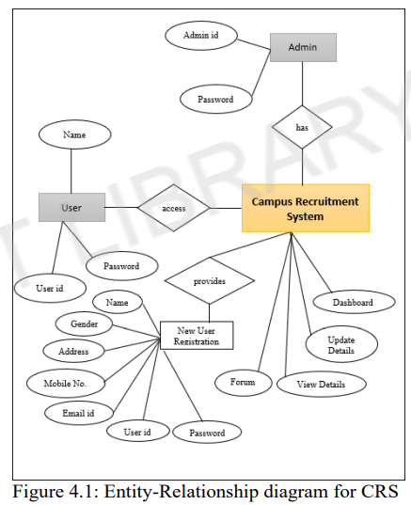

Description: The Entity-Relationship diagram shown in Figure 4.1 shows the relationship between the main components and features of CRS. Student, company and admin can login into the system.

New user needs to register rst and then they can login using their user id and password.

**4.2 Activity Diagram**

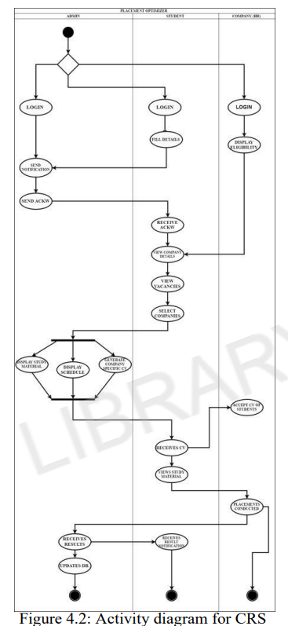

Description: In this activity diagram, shown in Figure 4.2, there are three main roles- Admin, Student and company. Admin will be able to Login in to the system. After login, Admin can send noti cations and acknowledgements. Students can ll details, receive acknowledgement, view company details, view vacancies, select companies. After lling up data, admin can display study material, display schedule, generate company speci c CV. Companies can receive CV of students, conduct test, admin updates the database.

**4.3 Functional Modeling**

**4.3.1 Level 0 DFD**

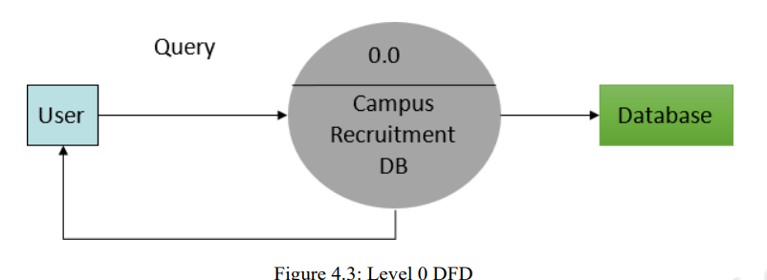

Description: The DFD, shown in Figure 4.3, gives an overview of information sharing between the user and the database. The required information is fetched from the database and returned back to the user.

**4.3.2 Level 1 DFD**

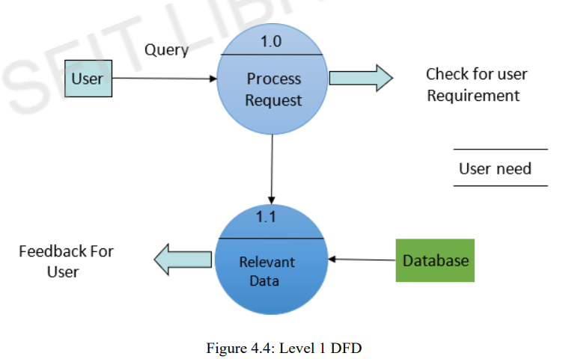

Description: The above Figure 4.4 shows the Level 1 DFD for the CRS. It gives a detailed information of data sharing between user and database. User requests a query to the CRS database, database checks for relevant data and if present , returns it back to the user.

4.3.3 Level 2 DFD

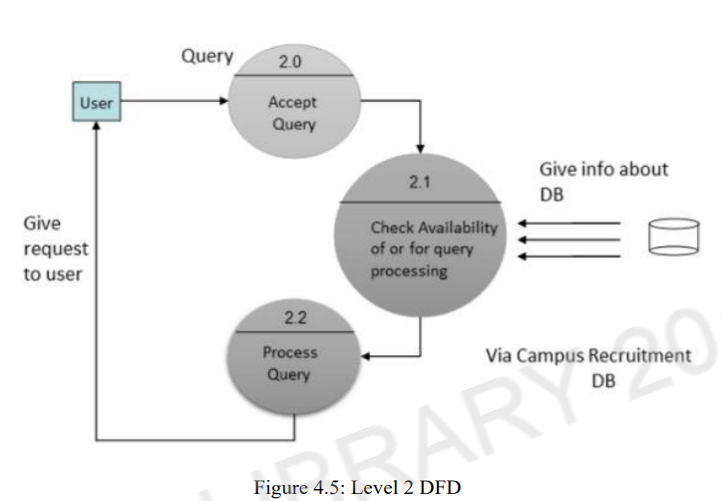

Description: The above Figure 4.5 shows the Level 2 DFD for the CRS. User requests a query to the database. System accepts user query and checks in the database for availability of information in the database and processes the query and data is returned back to the user.

**4.4 Timeline Chart**

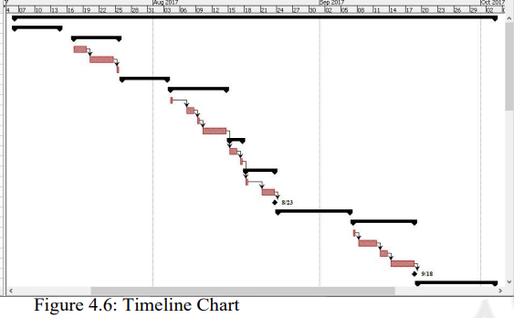

Description: The above Figure 4.6 shows the timeline chart of our project. It shows a series of events in chronological order over a linear timescale. It makes it easy to understand critical milestones, such as the progress of a project schedule with the help of timeline chart.

**5. Design**

**5.1 Architectural Design**

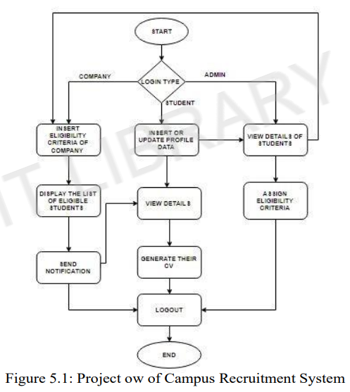

Description: The above Figure 5.1 shows the owchart of the CRS. In our project, there are three actors- Admin, Company and Student. Each actor need to register themselves in the system. After that, each will be able to login with their unique login IDs. After Admin logs in, he will be able to view all the registered students, view company details, insert eligibility criteria of the companies, display the list of eligible students and send noti cations about interview schedules, etc. After Students login, they will be able to insert or update pro le data, view details of company, view noti cations sent by the Admin, post queries related to placements.

**5.2 future User Interface Design**



Description: The homepage shown in Figure 5.2 is the main page of the CRS. It consist of three buttons: Admin login, Student login, Company login, TnP Schedule and FAQ.

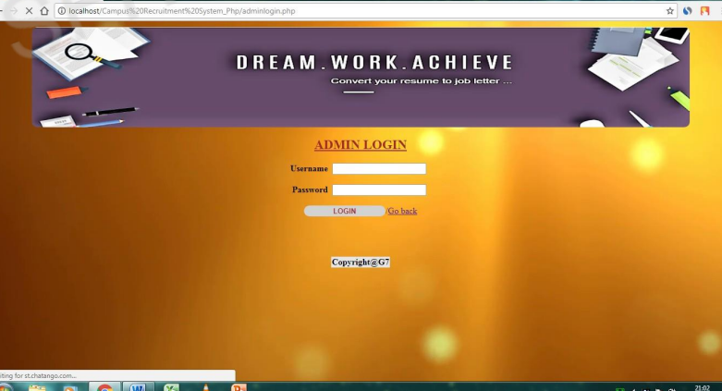

Description: The admin login page shown in Figure 5.3 allows the administrator or the TPO to login and manage student and company data. We can redirect it to home page also.

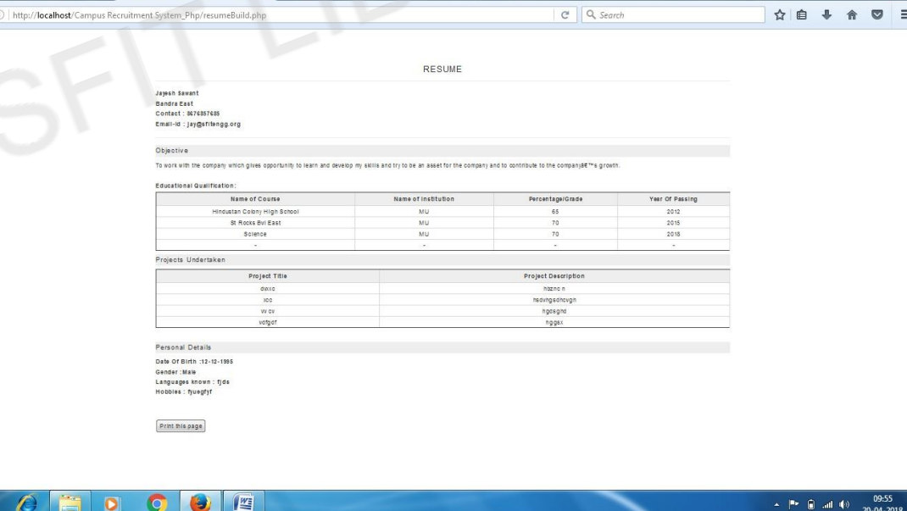 Description: The above Figure 5.6 shows the format of the CV of CRS. The CV has a standard format.

**5.3 WATERFALL MODEL**

The waterfall model was selected as the SDLC model due to the following reasons:

* Requirements were very well documented, clear and fixed.
* Technology was adequately understood.
* Simple and easy to understand and use.
* There were no ambiguous requirements.
* Easy to manage due to the rigidity of the model. Each phase has specific deliverables and a review process.
* Clearly defined stages.
* Well understood milestones.Easy to arrange tasks.

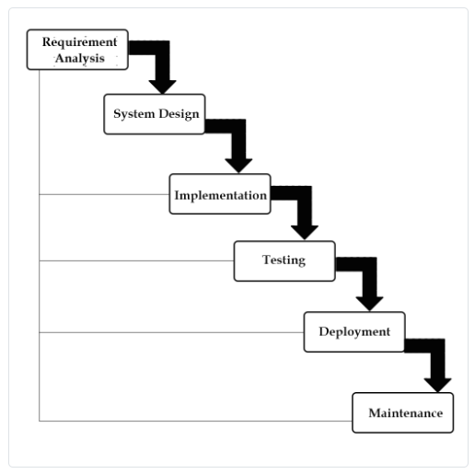

**6. Implementation**

**6.1 Technologies Used**

**PHP:**

PHP can handle forms, i.e. gather data from les, save data to a le, thru email you can send data, return data to the user.

• You add, delete and modify elements within your database thru PHP.

• Access cookies variables and set cookies.

• Using PHP, you can restrict users to access some pages of your website.

• It can encrypt data.

**Environment Setup:**

In order to develop and run PHP Web pages, three vital components need to be installed on your computer system.

Web Server - PHP will work with virtually all Web Server software, including Microsoft's Internet Information Server (IIS) but then most often used is freely available Apache Server.

Database - PHP will work with virtually all database software, including Oracle and Sybase but most commonly used is freely available MySQL database.

PHP Parser - In order to process PHP script instructions, a parser must be installed to generate HTML output that can be sent to the Web Browser.

**WAMP:**

It is a Windows OS-based program that installs and con gures Apache web server, MySQL database server, PHP scripting language, phpMyAdmin (to manage MySQL databases), and SQLiteManager (to manage SQLite databases). WAMP is designed to o er an easy way to install Apache, PHP, and MySQL packages with an easy-to-use installation program instead of having to install and con sure everything yourself.

WAMP is so easy because once it is installed it is ready to go. You don't have to do any additional con during or tweaking of any con guration les to get it running. There are usually two reasons why someone chooses to install WAMP. They are looking to install WAMP for development purposes or to run their own server.

**PHP Admin:**

Allows you to change or add users and for making new databases phpMyAdmin is a free software tool written in PHP, intended to handle the administration of MySQL the World Wide Web. phpMyAdmin supports a wide range of operations with MySQL. SQL Server and Database System SQL Server is a relational database management system from Microsoft that's designed for the enterprise environment.

**Using WAMP as a Development Server:**

You can use WAMP to develop and test websites locally on their own computer instead of having to get a web hosting account to develop with. Most people will be using WAMP for development purposes such as learning how to create websites with HTML, PHP, and MySQL.

**Using WAMP as a Production Server:**

It was designed to be a testing and development server, not an actual production server. WAMP does not come with any real security in place so it o ers no protection from any kind of attack. Any 10 year old with access to the internet can easily hack your WAMP server. If your website(s) have highly sensitive data (such as credit card numbers, social security numbers, user ids, passwords, etc.), you need to take this in consideration before your put this information online.

**6.2 Working of Project**

**AdminLogin:**

Here, the admin oftheCampusRecruitmentwebsite put his credentials in the Login page.

**Student Login:**

Here, the student of the Campus Recruitment website put his credentials in the Login page.

**Company Login:**

Here, the company of the Campus Recruitment website put their credentials in the Login page.

**Company views student data:**

Here, various company's views data of students to recruit them.

**Student can view company data:**

Here, various students views data of companies and apply accordingly.

**Forum:**

Here, people could discuss on multiple topic and share their views or chat with other people.

**Admin dashboard:**

Here, admin has overall functional rights to modify data & manage it.

**Appropriate data processing and handling**:

After ring any of the query by admin/students/companies, appropriate data is processed and handled.

**Chatbox:**

In chatbox, anyone can ask question to admin. Anyone can answer the query

Top of Form

**6.2.1 EXECUTION CODE**

import numpy as np

import pandas as pd

import matplotlib.pyplot as plt

import seaborn as sns

import sklearn

placement = pd.read_csv("PlacementDataset.csv")

placement.head()

placement_copy=placement.copy()

placement_copy.shape

placement_copy.dtypes

placement_copy.isnull().sum()

placement_copy['salary'].fillna(value=0 , inplace = True )

placement_copy.isnull().sum()

placement_copy.isnull().sum()

placement_copy.head(10)

plt.figure(figsize = (15,10))

ax = plt.subplot(221)

plt.boxplot(placement_copy['ssc_p'])

ax.set_title('Secondary School Percentage')

ax = plt.subplot(222)

plt.boxplot(placement_copy['hsc_p'])

ax.set_title('Higher secondary Percentage')

ax = plt.subplot(223)

plt.boxplot(placement_copy['degree_p'])

ax.set_title('UG Percentage')

ax = plt.subplot(224)

plt.boxplot(placement_copy['etest_p'])

ax.set_title('Employability Percentage')

Q1 = placement_copy['hsc_p'].quantile(0.25)

Q3 = placement_copy['hsc_p'].quantile(0.75)

IQR = Q3 - Q1

filter = (placement_copy['hsc_p'] >= Q1 - 1.5 * IQR) & (placement_copy['hsc_p']<= Q3+ 1.5*IQR)

placement_filtered= placement_copy.loc[filter]

plt.boxplot(placement_filtered['hsc_p'])

plt.figure(figsize = (15,7))

plt.subplot(231)

ax = sns.countplot(x= 'gender' , data = placement_filtered)

plt.subplot(232)

ax = sns.countplot(x= 'hsc_s' , data = placement_filtered)

plt.subplot(233)

ax = sns.countplot(x= 'degree_t' , data = placement_filtered)

plt.subplot(234)

ax = sns.countplot(x= 'specialisation' , data = placement_filtered)

plt.subplot(235)

ax = sns.countplot(x= 'workex' , data = placement_filtered)

plt.subplot(236)

ax = sns.countplot(x= 'status' , data = placement_filtered)

placement_placed = placement_filtered[placement_filtered.salary!= 0]

sns.distplot(placement_placed['salary'])

import plotly.express as px

px.violin(placement_placed,y="salary",x="specialisation",color="gender",box=True,points="all")

object_cols= ['gender','workex','specialisation','status']

label_encoder = LabelEncoder()

for col in object_cols:

placement_filtered[col]= label_encoder.fit_transform(placement_filtered[col])

placement_filtered.head(10)

X = placement_coded.drop(['status'],axis=1)

y = placement_coded.status

from sklearn.model_selection import train_test_split

X_train, X_test, y_train, y_test = train_test_split(X , y , train_size = 0.8 , random_state = 1)

import warnings

warnings.filterwarnings('ignore')

from sklearn.linear_model import LogisticRegression

from sklearn import metrics

logreg = LogisticRegression()

logreg.fit(X_train , y_train)

y_pred = logreg.predict(X_test)

print(logreg.score(X_test , y_test))

from sklearn.tree import DecisionTreeClassifier

dt = DecisionTreeClassifier(criterion = 'gini' , max_depth = 3)

dt = dt.fit(X_train , y_train)

y_pred = dt.predict(X_test)

print("Accuracy", metrics.accuracy_score(y_test , y_pred))

from sklearn.ensemble import RandomForestClassifier

rt = RandomForestClassifier(n_estimators = 100)

rt.fit(X_train , y_train)

y_pred = rt.predict(X_test)

print("Accuracy", metrics.accuracy_score(y_test , y_pred))

**6.2.2 ORIGINAL EXECUTION SCREENSHOTS**

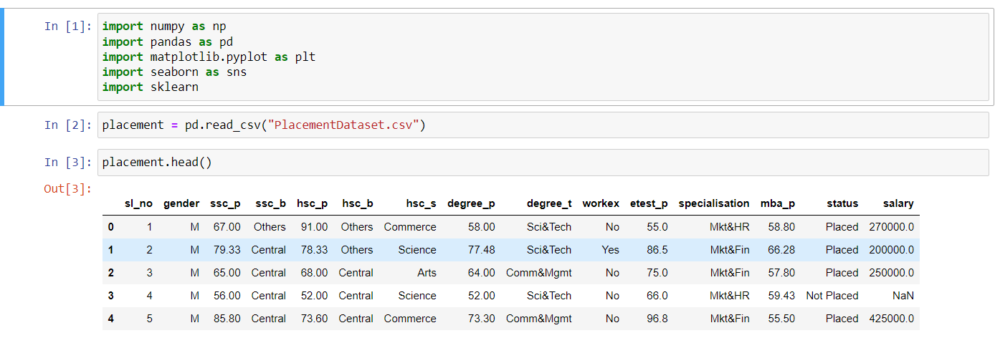

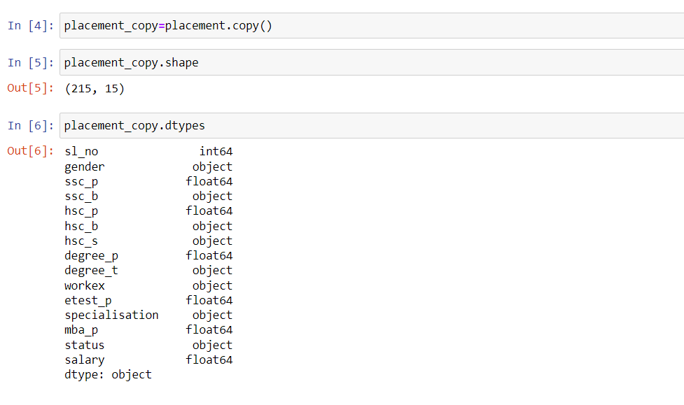

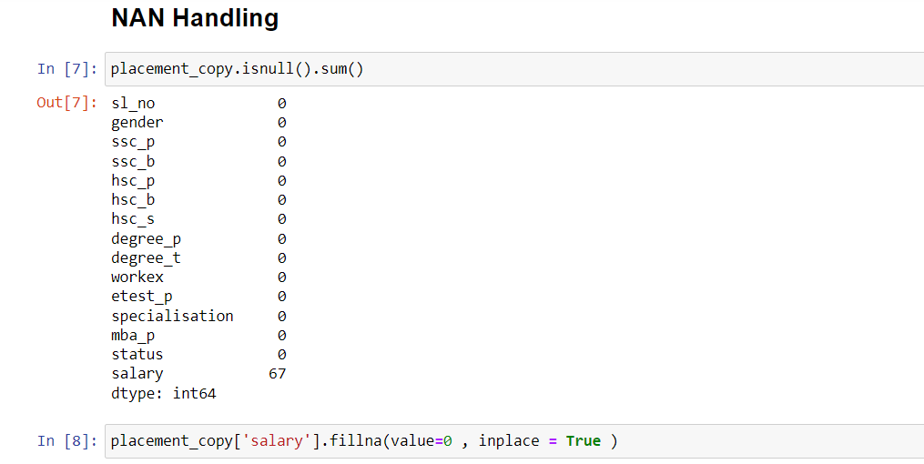

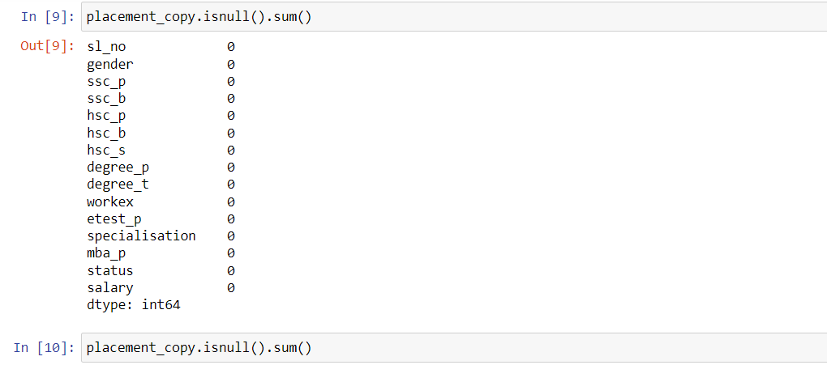

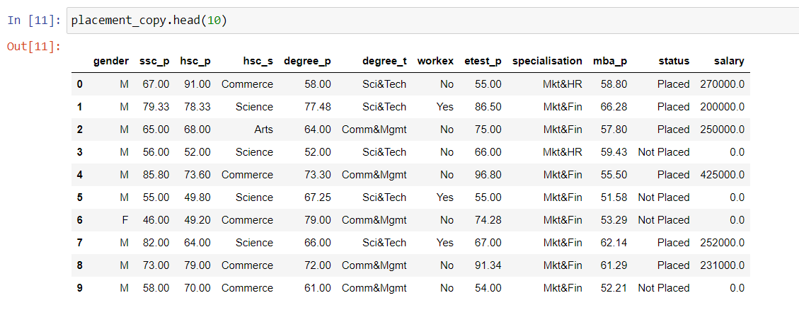

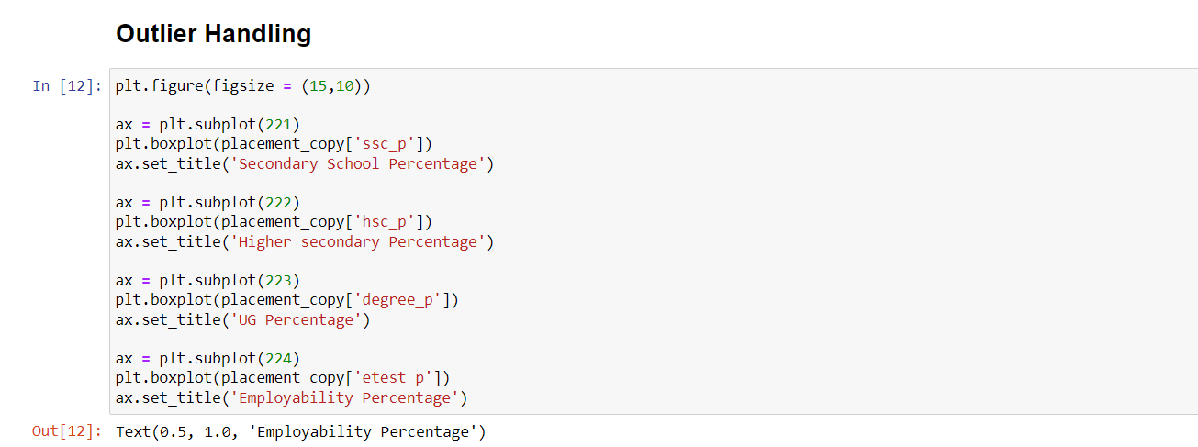

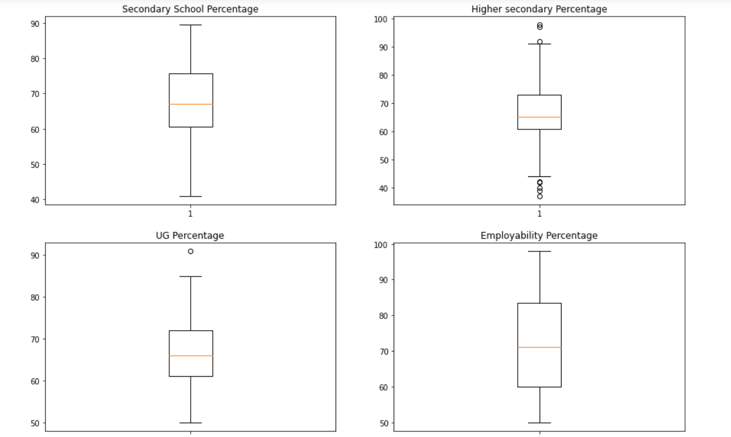

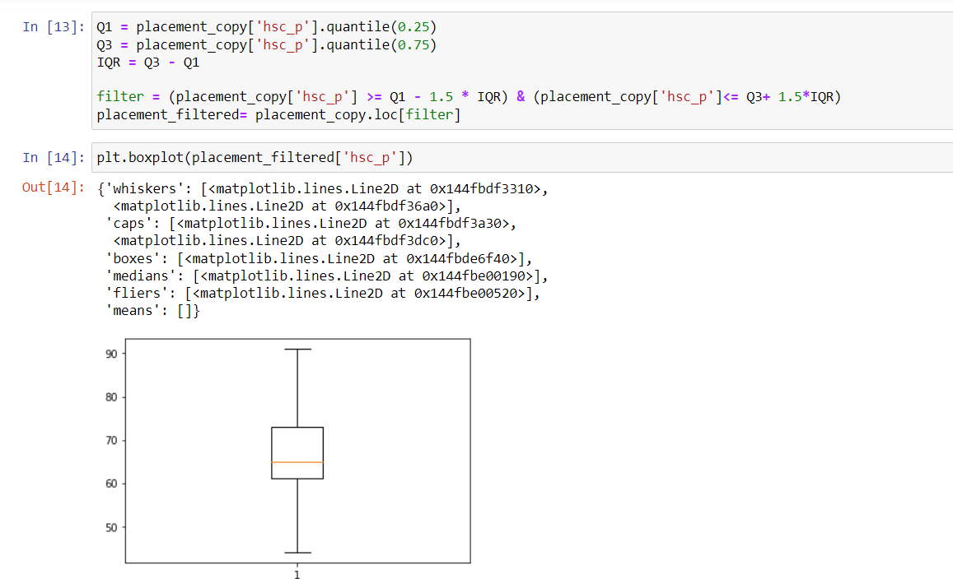

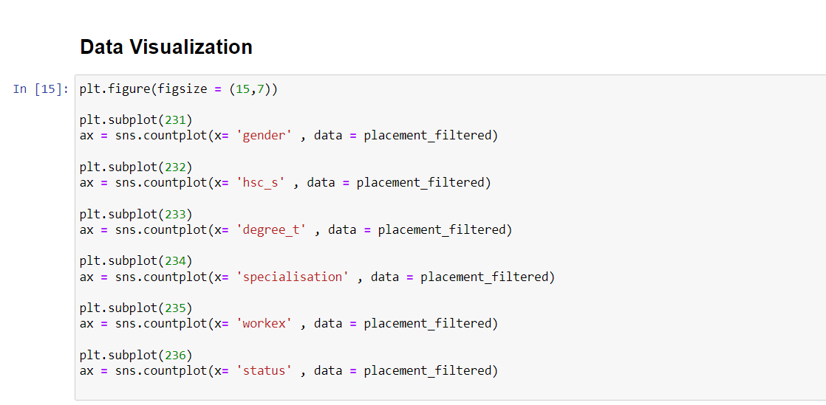

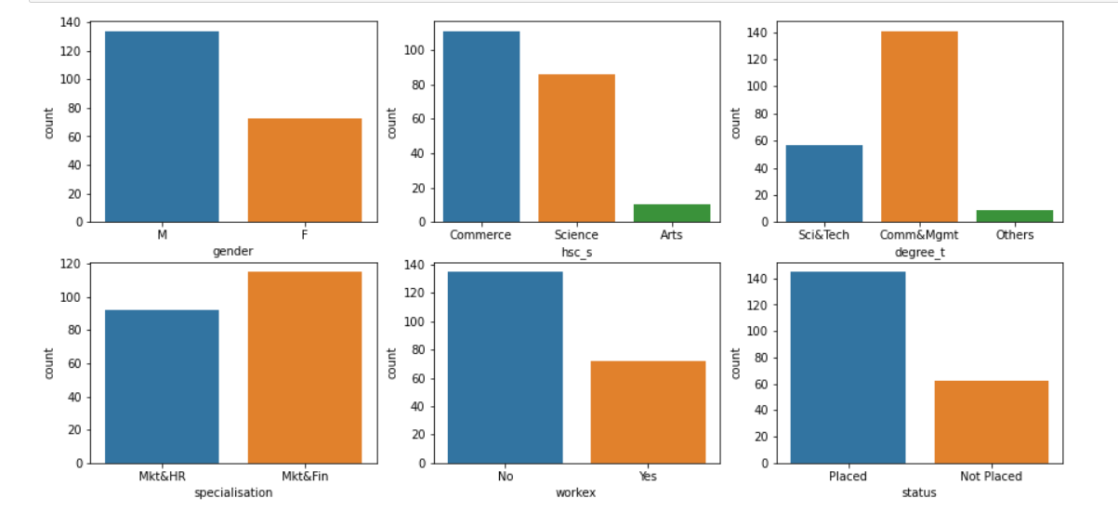

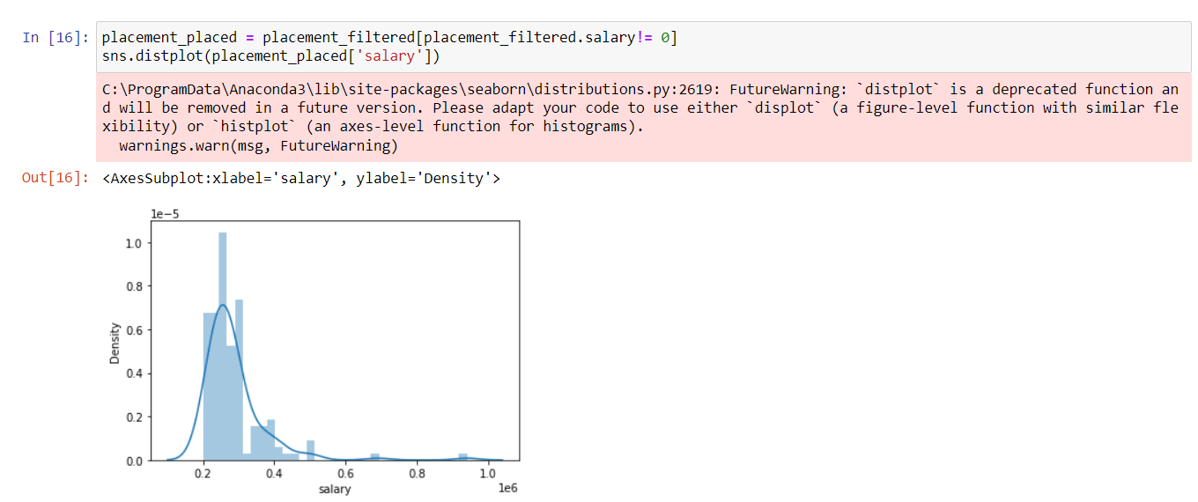

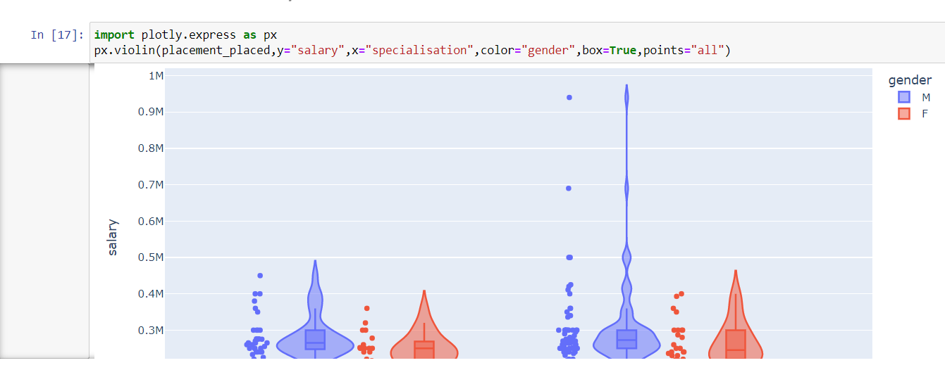

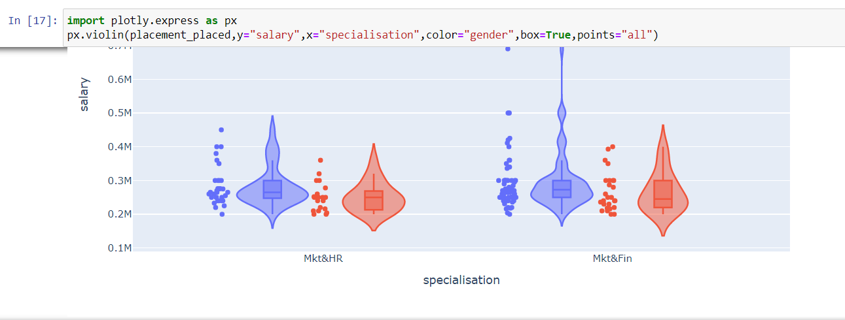

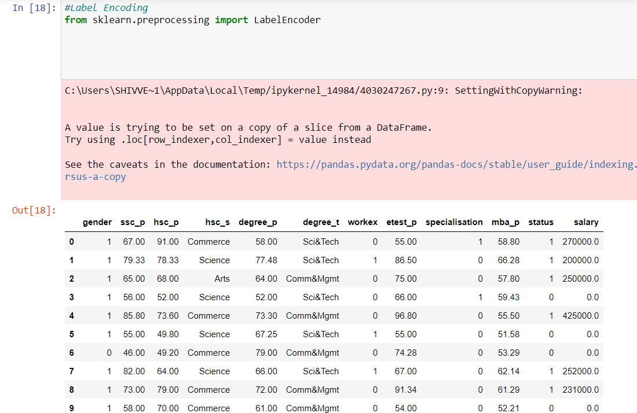

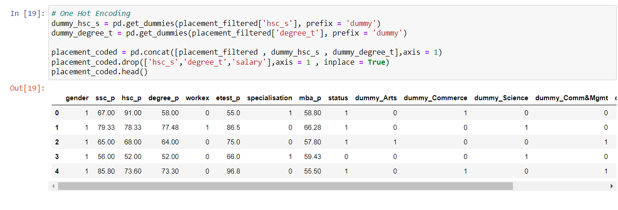

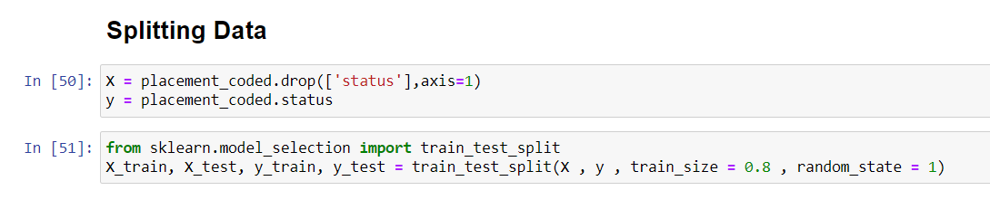

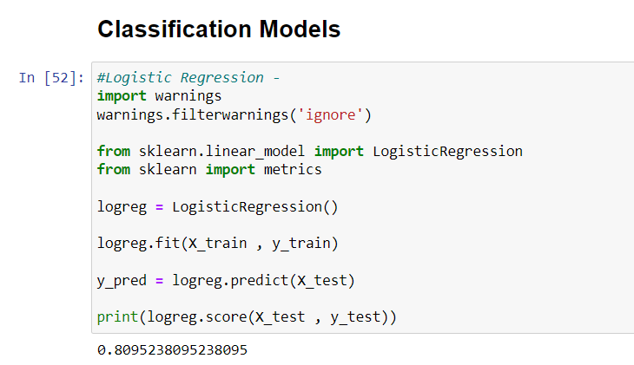

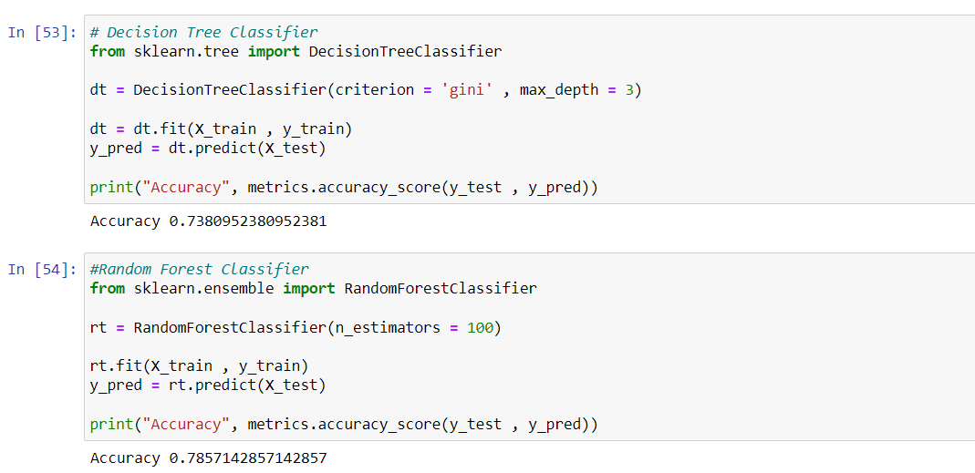

**6.3 Implementation Details**

**6.3.1 front end**

**HTML**

Hypertext Markup Language (HTML) is the standard markup language for documents designed to be displayed in a web browser. It can be assisted by technologies such as Cascading Style Sheets (CSS) and scripting languages such as JavaScript. Web browsers receive HTML documents from a web server or from local storage and render the documents into multimedia web pages. HTML describes the structure of a web page semantically and originally included cues for the appearance of the document.

HTML elements are the building blocks of HTML pages. With HTML constructs, images and other objects such as interactive forms may be embedded into the rendered page. HTML provides a means to create structured documents by denoting structural semantics for text such as headings, paragraphs, lists, links, quotes and other items. HTML elements are delineated by tags, written using angle brackets. Tags such as <img /> and <input /> directly introduce content into the page. Other tags such as <p> surround and provide information about document text and may include other tags as sub-elements. Browsers do not display the HTML tags, but use them to interpret the content of the page.

HTML can embed programs written in a scripting language such as JavaScript, which affects the behavior and content of web pages. Inclusion of CSS defines the look and layout of content. The World Wide Web Consortium (W3C), former maintainer of the HTML and current maintainer of the CSS standards, has encouraged the use of CSS over explicit presentational HTML since 1997.

**Css**

Cascading Style Sheets (CSS) is a style sheet language used for describing the presentation of a document written in a markup language like HTML.CSS is a cornerstone technology of the World Wide Web, alongside HTML and JavaScript.CSS is designed to enable the separation of presentation and content, including layout, colors, and fonts.This separation can improve content accessibility, provide more flexibility and control in the specification of presentation characteristics, enable multiple web pages to share formatting by specifying the relevant CSS in a separate .css file, and reduce complexity and repetition in the structural content.

CSS information can be provided from various sources. These sources can be the web browser, the user and the author. The information from the author can be further classified into inline, media type, importance, selector specificity, rule order, inheritance and property definition. CSS style information can be in a separate document or it can be embedded into an HTML document. Multiple style sheets can be imported. Different styles can be applied depending on the output device being used; for example, the screen version can be quite different from the printed version, so that authors can tailor the presentation appropriately for each medium.The style sheet with the highest priority controls the content display. Declarations not set in the highest priority source are passed on to a source of lower priority, such as the user agent style. The process is called cascading.

One of the goals of CSS is to allow users greater control over presentation. Someone who finds red italic headings difficult to read may apply a different style sheet. Depending on the browser and the web site, a user may choose from various style sheets provided by the designers, or may remove all added styles and view the site using the browser's default styling, or may override just the red italic heading style without altering other attributes.

**JavaScript**

JavaScript s a high-level, interpreted scripting language that conforms to the ECMAScript specification. JavaScript has curly-bracket syntax, dynamic typing, prototype-based object-orientation, and first-class functions.Alongside HTML and CSS, JavaScript is one of the core technologies of the World Wide Web.JavaScript enables interactive web pages and is an essential part of web applications. The vast majority of websites use it,and major web browsers have a dedicated JavaScript engine to execute it.As a multi-paradigm language, JavaScript supports event-driven, functional, and imperative (including object-oriented and prototype-based) programming styles. It has APIs for working with text, arrays, dates, regular expressions, and the DOM, but the language itself does not include any I/O, such as networking, storage, or graphics facilities. It relies upon the host environment in which it is embedded to provide these features.

Initially only implemented client-side in web browsers, JavaScript engines are now embedded in many other types of host software, including server-side in web servers and databases, and in non-web programs such as word processors and PDF software, and in runtime environments that make JavaScript available for writing mobile and desktop applications, including desktop widgets.

The terms Vanilla JavaScript and Vanilla JS refer to JavaScript not extended by any frameworks or additional libraries. Scripts written in Vanilla JS are plain JavaScript code.Google's Chrome extensions, Opera's extensions, Apple's Safari 5 extensions, Apple's Dashboard Widgets, Microsoft's Gadgets, Yahoo! Widgets, Google Desktop Gadgets, and Serence Klipfolio are implemented using JavaScript.

**6.3.2 Back End**

**PHP**

PHP is a server side scripting language that is used to develop Static websites or Dynamic websites or Web applications. PHP stands for Hypertext Pre-processor, that earlier stood for Personal Home Pages. PHP scripts can only be interpreted on a server that has PHP installed. The client computers accessing the PHP scripts require a web browser only. A PHP file contains PHP tags and ends with the extension ".php".

The term PHP is an acronym for PHP: Hypertext Preprocessor. PHP is a server-side scripting language designed specifically for web development. PHP can be easily embedded in HTML files and HTML codes can also be written in a PHP file. The thing that differentiates PHP with client-side language like HTML is, PHP codes are executed on the server whereas HTML codes are directly rendered on the browser.

PHP: Hypertext Preprocessor (or simply PHP) is a general-purpose programming language originally designed for web development. It was originally created by Rasmus Lerdorf in 1994.PHP code may be executed with a command line interface (CLI), embedded into HTML code, or used in combination with various web template systems, web content management systems, and web frameworks. PHP code is usually processed by a PHP interpreter implemented as a module in a web server or as a Common Gateway Interface (CGI) executable. The web server outputs the results of the interpreted and executed PHP code, which may be any type of data, such as generated HTML code or binary image data. PHP can be used for many programming tasks outside of the web context, such as standalone graphical applications and robotic drone control.

**MySQL**

MySQL is an open source relational database management system (RDBMS) based on Structured Query Language (SQL). It is one part of the very popular LAMP platform consisting of Linux, Apache, My SQL, and PHP. Currently My SQL is owned by Oracle. My SQL database is available on most important OS platforms. It runs on BSD Unix, Linux, Windows, or Mac OS. Wikipedia and YouTube use My SQL. These sites manage millions of queries each day. My SQL comes in two versions: My SQL server system and My SQL embedded system.

RDBMS TERMINOLOGY

Before we proceed to explain MySQL database system, let's revise few definitions related to database.

* **Database:**A database is a collection of tables, with related data.
* **Table:**A table is a matrix with data. A table in a database looks like a simple spadsheet.
* **Column:**One column (data element) contains data of one and the same kind, for example the column postcode.
* **Row:**A row (= tuple, entry or record) is a group of related data, for example the data of one subscription.
* **Redundancy:**Storing data twice, redundantly to make the system faster.
* **Primary Key:**A primary key is unique. A key value cannot occur twice in one table. With a key, you can find at most one row.
* **Foreign Key:**A foreign key is the linking pin between two tables.
* **Compound Key:**A compound key (composite key) is a key that consists of multiple columns, because one column is not sufficiently unique.
* **Index:**An index in a database resembles an index at the back of a book.
* **Referential Integrity:**Referential Integrity makes sure that a foreign key value always points to an existing row.

# 6.4 Campus Placement prediction using Logistic Regression

In this article, we are going to discuss how to predict the placement status of a student based on various student attributes using the Logistic regression algorithm.

Placements hold great importance for students and educational institutions. It helps a student to build a strong foundation for the professional career ahead as well as a good placement record gives a competitive edge to a college/university in the education market.

This study focuses on a system that predicts if a student would be placed or not based on the student’s qualifications, historical data, and experience. This predictor uses a machine-learning algorithm to give the result.

The algorithm used is logistic regression. Logistic regression is basically a supervised classification algorithm. In a classification problem, the target variable(or output), y, can take only discrete values for a given set of features(or inputs), X. Talking about the dataset, it contains the secondary school percentage, higher secondary school percentage, degree percentage, degree, and work experience of students.

After predicting the result its efficiency is also calculated based on the dataset. The dataset used here is in *.csv* format.

### ****Below is the step-by-step Approach:****

**Step 1:** Import the required modules.

# import modules

**import** pandas as pd

**import** numpy as np

**import** matplotlib.pyplot as plt

**Step 2:** Now to read the dataset that we are going to use for the analysis and then checking the dataset

# reading the file

dataset **=** pd.read_csv('Placement_Data_Full_Class.csv')

dataset

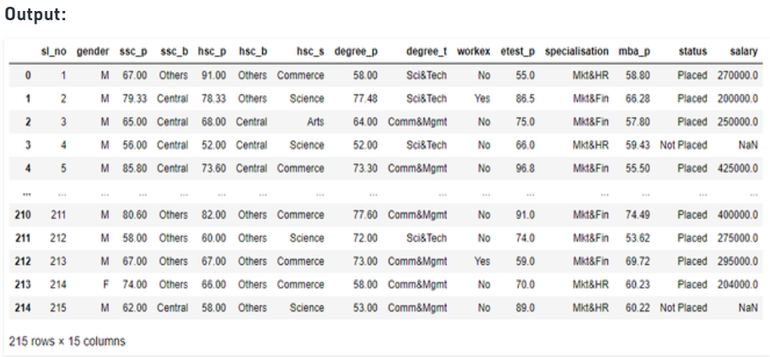

**Step 3:** Now we will drop the columns that are not needed.

# dropping the serial no and salary col

dataset **=** dataset.drop('sl_no', axis**=**1)

dataset **=** dataset.drop('salary', axis**=**1)

**Step 4:** Now before moving forward we need to pre-process and transform our data. For that, we will use *astype()* method on some columns and change the datatype to *category*.

# catgorising col for further labelling

dataset["gender"] **=** dataset["gender"].astype('category')

dataset["ssc_b"] **=** dataset["ssc_b"].astype('category')

dataset["hsc_b"] **=** dataset["hsc_b"].astype('category')

dataset["degree_t"] **=** dataset["degree_t"].astype('category')

dataset["workex"] **=** dataset["workex"].astype('category')

dataset["specialisation"] **=** dataset["specialisation"].astype('category')

dataset["status"] **=** dataset["status"].astype('category')

dataset["hsc_s"] **=** dataset["hsc_s"].astype('category')

dataset.dtypes

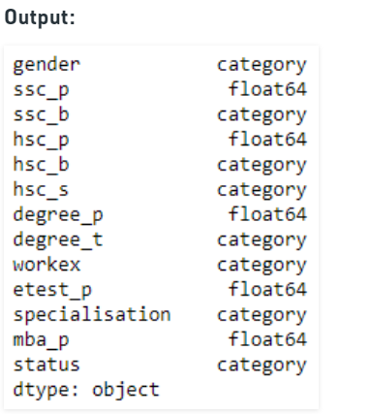

**Step 5:** Now we will apply codes on some of these columns to convert their text values to numerical values.

|  |
| --- |
| # labelling the columns  dataset["gender"] **=** dataset["gender"].cat.codes  dataset["ssc_b"] **=** dataset["ssc_b"].cat.codes  dataset["hsc_b"] **=** dataset["hsc_b"].cat.codes  dataset["degree_t"] **=** dataset["degree_t"].cat.codes  dataset["workex"] **=** dataset["workex"].cat.codes  dataset["specialisation"] **=** dataset["specialisation"].cat.codes  dataset["status"] **=** dataset["status"].cat.codes  dataset["hsc_s"] **=** dataset["hsc_s"].cat.codes    # display dataset  dataset |

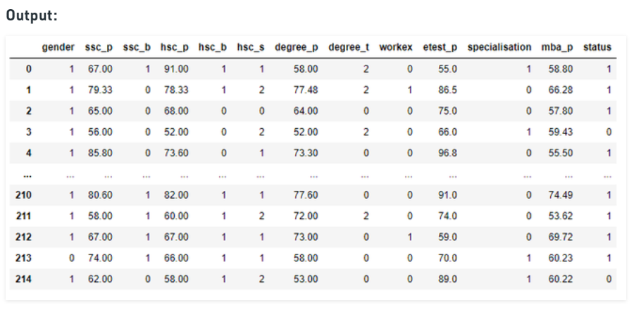

**Step 6:** Now to split the dataset into features and values using *iloc()* function:

|  |
| --- |
| # selecting the features and labels  X **=** dataset.iloc[:, :**-**1].values  Y **=** dataset.iloc[:, **-**1].values    # display dependent variables  Y |

**Step 7:** Now we will split the dataset into train and test data which will be used to check the efficiency later.

|  |
| --- |
| # dividing the data into train and test  **from** sklearn.model_selection **import** train_test_split  X_train, X_test, Y_train, Y_test **=** train_test_split(X, Y,                                                      test_size**=**0.2)    # display dataset  dataset.head() |

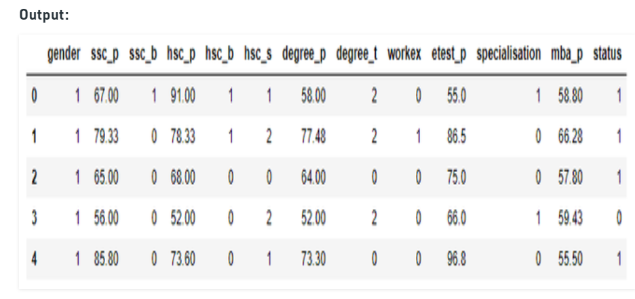

**Step 8:** Now we need to train our model for which we will need to import a file, and then we will create a classifier using *sklearn*module. Then we will check the accuracy of the model.

|  |
| --- |
| # creating a classifier using sklearn  **from** sklearn.linear_model **import** LogisticRegression    clf **=** LogisticRegression(random_state**=**0, solver**=**'lbfgs',                           max_iter**=**1000).fit(X_train,                                              Y_train)  # printing the acc  clf.score(X_test, Y_test) |

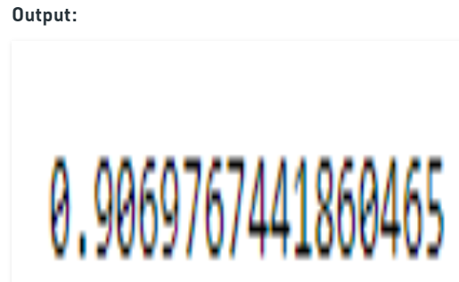

**Step 9:** Once we have trained the model, we will check it giving some random values:

|  |
| --- |
| # predicting for random value  clf.predict([[0, 87, 0, 95, 0, 2, 78, 2, 0, 0, 1, 0]]) |

**Step 10:** To gain a more nuanced understanding of our model’s performance we need to make a confusion matrix. A confusion matrix is a table with two rows and two columns that reports the number of false positives, false negatives, true positives, and true negatives.

To get the confusion matrix it takes in two arguments: The actual labels of your test set *y_test* and predicted labels. The predicted labels of the classifier are stored in *y_pred* as follows:

* Python

|  |
| --- |
| # creating a Y_pred for test data  Y_pred **=** clf.predict(X_test)    # display predicted values  Y_pred |

**7 TESTING ABOVE IMPLEMENTATION**

The term implementation has different meanings ranging from the conversation of a basic application to a complete replacement of a computer system. The procedures however, are virtually the same. Implementation includes all those activities that take place to convert from old system to new. The new system may be totally new replacing an existing manual or automated system or it may be major modification to an existing system. The method of implementation and time scale to be adopted is found out initially. Proper implementation is essential to provide a reliable system to meet organization requirement.

**7.1 : UNIT TESTING**

**7.1.1 Introduction**

In computer programming, unit testing is a software testing method by which individual units of source code, sets of one or more computer program modules together with associated control data, usage procedures, and operating procedures, are tested to determine whether they are fit for use. Intuitively, one can view a unit as the smallest testable part of an application. In procedural programming, a unit could be an entire module, but it is more commonly an individual function or procedure. In object-oriented programming, a unit is often an entire interface, such as a class, but could be an individual method. Unit tests are short code fragments created by programmers or occasionally by white box testers during the development process. It forms the basis for component testing. Ideally, each test case is independent from the others. Substitutes such as method stubs, mock objects, fakes, and test harnesses can be used to assist testing a module in isolation. Unit tests are typically written and run by software developers to ensure that code meets its design and behaves as intended.

**7.1.2 Benifits**

The goal of unit testing is to isolate each part of the program and show that the individual parts are correct. A unit test provides a strict, written contract that the piece of code must satisfy. As a result, it affords several benefits::

**1) Find problems early :**Unit testing finds problems early in the development cycle. In test-driven development (TDD), which is frequently used in both extreme programming and scrum, unit tests are created before the code itself is written. When the tests pass, that code is considered complete. The same unit tests are run against that function frequently as the larger code base is developed either as the code is changed or via an automated process with the build. If the unit tests fail, it is considered to be a bug either in the changed code or the tests themselves. The unit tests then allow the location of the fault or failure to be easily traced. Since the unit tests alert the development team of the problem before handing the code off to testers or clients, it is still early in the development process.

**2 ) Facilitates Change :**Unit testing allows the programmer to refactor code or upgrade system libraries at a later date, and make sure the module still works correctly (e.g., in regression testing). The procedure is to write test cases for all functions and methods so that whenever a change causes a fault, it can be quickly identified. Unit tests detect changes which may break a design contract.

1. **) Simplifies Integration :**Unit testing may reduce uncertainty in the units themselves and can be used in a bottom-up testing style approach. By testing the parts of a program first and then testing the sum of its parts, integration testing becomes much easier.

**4 ) Documentation :**Unit testing provides a sort of living documentation of the system. Developers looking to learn what functionality is provided by a unit, and how to use it, can look at the unit tests to gain a basic understanding of the unit's interface (API).Unit test cases embody characteristics that are critical to the success of the unit.

**7.2 : INTEGRATION TESTING**

Integration testing (sometimes called integration and testing, abbreviated I&T) is the phase in software testing in which individual software modules are combined and tested as a group. It occurs after unit testing and before validation testing. Integration testing takes as its input modules that have been unit tested, groups them in larger aggregates, applies tests defined in an integration test plan to those aggregates, and delivers as its output the integrated system ready for system testing.

**7.2.1 Purpose**

The purpose of integration testing is to verify functional, performance, and reliability requirements placed on major design items. These "design items", i.e., assemblages (or groups of units), are exercised through their interfaces using black-box testing, success, and error cases being simulated via appropriate parameters and data inputs.Test cases are constructed to test whether all the components within assemblages interact correctly, for example across procedure calls or process activations, and this is done after testing individual modules, i.e., unit testing.

The overall idea is a "building block" approach, in which verified assemblages are added to a verified base which is then used to support the integration testing of further assemblages. Software integration testing is performed according to the software development life cycle (SDLC) after module and functional tests. The cross-dependencies for software integration testing are: schedule for integration testing, strategy, and selection of the tools used for integration, defining the cyclomatic complexity of the software and software architecture, reusability of modules and life-cycle, and versioning management. Some different types of integration testing are big-bang, top-down, bottom-up, mixed (sandwich), and risky-hardest. Other Integration Patterns[2] are collaboration integration, backbone integration, layer integration, client-server integration, distributed services integration, and high-frequency integration.

**7.2.1.1 Big Bang**

In the big-bang approach, most of the developed modules are coupled together to form a complete software system or major part of the system and then used for integration testing. This method is very effective for saving time in the integration testing process. However, if the test cases and their results are not recorded properly, the entire integration process will be more complicated and may prevent the testing team from achieving the goal of integration testing.A type of big-bang integration testing is called "usage model testing" which can be used in both software and hardware integration testing. The basis behind this type of integration testing is to run user-like workloads in integrated user-like environments. In doing the testing in this manner, the environment is proofed, while the individual components are proofed indirectly through their use. Usage Model testing takes an optimistic approach to testing, because it expects to have few problems with the individual components.

**7.2.1.2 Top-down And Bottom-up**

Bottom-up testing is an approach to integrated testing where the lowest level components are tested first, then used to facilitate the testing of higher level components. The process is repeated until the component at the top of the hierarchy is tested.All the bottom or low-level modules, procedures or functions are integrated and then tested. After the integration testing of lower level integrated modules, the next level of modules will be formed and can be used for integration testing. This approach is helpful only when all or most of the modules of the same development level are ready. This method also helps to determine the levels of software developed and makes it easier to report testing progress in the form of a percentage.Top-down testing is an approach to integrated testing where the top integrated modules are tested and the branch of the module is tested step by step until the end of the related module.Sandwich testing is an approach to combine top down testing with bottom up testing.

**7.3 : SOFTWARE VERIFICATION AND VALIDATION**

**7.3.1 Introduction**

In software project management, software testing, and software engineering, verification and validation (V&V) is the process of checking that a software system meets specifications and that it fulfills its intended purpose. It may also be referred to as software quality control. It is normally the responsibility of software testers as part of the software development lifecycle. Validation checks that the product design satisfies or fits the intended use (high-level checking), i.e., the software meets the user requirements.This is done through dynamic testing and other forms of review.

Verification and validation are not the same thing, although they are often confused. Boehm succinctly expressed the difference between

* Validation : Are we building the right product?
* Verification : Are we building the product right?

According to the Capability Maturity Model

Software Verification: The process of evaluating software to determine whether the products of a given development phase satisfy the conditions imposed at the start of that phase.

Software Validation: The process of evaluating software during or at the end of the development process to determine whether it satisfies specified requirements.

In other words, software verification is ensuring that the product has been built according to the requirements and design specifications, while software validation ensures that the product meets the user's needs, and that the specifications were correct in the first place. Software verification ensures that "you built it right". Software validation ensures that "you built the right thing". Software validation confirms that the product, as provided, will fulfill its intended use.

From Testing Perspective

* Fault – wrong or missing function in the code.
* Failure – the manifestation of a fault during execution.
* Malfunction – according to its specification the system does not meet its specified functionality

Both verification and validation are related to the concepts of quality and of software quality assurance. By themselves, verification and validation do not guarantee software quality; planning, traceability, configuration management and other aspects of software engineering are required.Within the modeling and simulation (M&S) community, the definitions of verification, validation and accreditation are similar:

* M&S Verification is the process of determining that a ⦁ computer model, simulation, or federation of models and simulations implementations and their associated data accurately represent the developer's conceptual description and specifications.
* M&S Validation is the process of determining the degree to which a model, simulation, or federation of models and simulations, and their associated data are accurate representations of the real world from the perspective of the intended use(s).

**7.3.2 Classification of Methods**

In mission-critical software systems, where flawless performance is absolutely necessary, formal methods may be used to ensure the correct operation of a system. However, often for non-mission-critical software systems, formal methods prove to be very costly and an alternative method of software V&V must be sought out. In such cases, syntactic methods are often used.

**7.3.3 Test Cases**

A test case is a tool used in the process. Test cases may be prepared for software verification and software validation to determine if the product was built according to the requirements of the user. Other methods, such as reviews, may be used early in the life cycle to provide for software validation.

**7.4 : Black-Box Testing**

Black-box testing is a method of software testing that examines the functionality of an application without peering into its internal structures or workings. This method of test can be applied virtually to every level of software testing: unit, integration, system and acceptance. It typically comprises most if not all higher level testing, but can also dominate unit testing as well.

**7.4.1 Test Procedures**

Specific knowledge of the application's code/internal structure and programming knowledge in general is not required. The tester is aware of what the software is supposed to do but is not aware of how it does it. For instance, the tester is aware that a particular input returns a certain, invariable output but is not aware of how the software produces the output in the first place.

**7.4.2 Test Cases**

Test cases are built around specifications and requirements, i.e., what the application is supposed to do. Test cases are generally derived from external descriptions of the software, including specifications, requirements and design parameters. Although the tests used are primarily functional in nature, non-functional tests may also be used.

**7.5 : White-Box Testing**

White-box testing (also known as clear box testing, glass box testing, transparent box testing, and structural testing) is a method of testing software that tests internal structures or workings of an application, as opposed to its functionality (i.e. black-box testing). In white-box testing an internal perspective of the system, as well as programming skills, are used to design test cases. The tester chooses inputs to exercise paths through the code and determine the appropriate outputs. This is analogous to testing nodes in a circuit, e.g. in-circuit testing (ICT). White-box testing can be applied at the unit, integration and system levels of the software testing process. Although traditional testers tended to think of white-box testing as being done at the unit level, it is used for integration and system testing more frequently today.

**7.5.1 Levels  of tests in campus recruitment**

**1 ) Unit testing :**White-box testing is done during unit testing to ensure that the code is working as intended, before any integration happens with previously tested code. White-box testing during unit testing catches any defects early on and aids in any defects that happen later on after the code is integrated with the rest of the application and therefore prevents any type of errors later on.

1. **) Integration testing :**White-box testing at this level are written to test the interactions of each interface with each other. The Unit level testing made sure that each code was tested and working accordingly in an isolated environment and integration examines the correctness of the behaviour in an open environment through the use of white-box testing for any interactions of interfaces that are known to the programmer.

**3 ) Regression testing :**White-box testing during regression testing is the use of recycled white-box test cases at the unit and integration testing levels.

**7.5.2 Procedures**

White-box testing's basic procedures involves the tester having a deep level of understanding of the source code being tested. These are the three basic steps that white-box testing takes in order to create test cases:

* Input involves different types of requirements, functional specifications, detailed designing of documents, proper source code, security specifications. This is the preparation stage of white-box testing to layout all of the basic information.
* Processing involves performing risk analysis to guide whole testing process, proper test plan, execute test cases and communicate results. This is the phase of building test cases to make sure they thoroughly test the application the given results are recorded accordingly.
* Output involves preparing final report that encompasses all of the above preparations and results.

**7.5.3 Advantages**

Campus recruitment activity offers several advantages to both the companies as well as the job applicants. Following are some of the main advantages of campus recruitment listed below --

1. The companies will be benefited from getting wide choice of candidates to select for different job posts. Companies can select the right and talented candidate from a vast pool of young applicants within a limited time. On the other hand, students have the advantage of getting a good job according to their qualification level even before the completion of their academic course in college.
2. Campus recruitment helps in saving time and efforts of the companies. The entire campus recruitment process from a college is not a tedious toil. It prevents the occurrence of unusual expenditures related to recruitment process such as advertisement, initial screening, and final selection procedures etc. This in turn turns to be useful in reduced manpower effort and time as well.
3. An organization through effective campus recruitment finds an opportunity to establish a link with the next batch of students. This in turn paves way to serve the future and long term recruitment needs of the company. Students participating in internships and summer training programs may have direct recruitment to different job positions offered by the company.
4. Campus recruitment helps in increased selection ratio. More number of quality candidates can be selected through this recruitment process.
5. The organizations can built up more company loyalty through campus selection process. Fresh and talented graduates will work more closely with their first company. Hence, this in a way will increase the brand loyalty among different applicants.
6. Further more are::

* It tracks all the information of college students, various companies visiting the campus for recruitment and even the college placement officer.
* Shows the information and description of the companies.
* Integration of all records of Company.
* To increase efficiency of managing Student qualification.

**7.5.5 Disadvantages  and Limitations**

Campus recruitment is an expensive affair for majority of the companies as it adds up costs to the bottom line. Companies incur different expenses related to travel, boarding, training etc while conducting campus selection process.

The experienced and skilled candidates having practical job exposures cannot be recruited through campus placements. Fresh candidates selected through campus placements require adequate training for work.

This is an additional expense for the company.  Also, students can’t work with their dream company and will have to remain satisfied with the company that recruits them during campus selection.

Campus recruitment is an expensive affair for majority of the companies as it adds up costs to the bottom line. Companies incur different expenses related to travel, boarding, training etc while conducting campus selection process.

The experienced and skilled candidates having practical job exposures cannot be recruited through campus placements. Fresh candidates selected through campus placements require adequate training for work.

This is an additional expense for the company. Also, students can’t work with their dream company and will have to remain satisfied with the company that recruits them during campus selection. The main disadvantages of campus recruitment are incurred high expenses for companies (in recruitment and training).

The companies will be benefited from getting wide choice of candidates to select for different job posts. Student can’t edit their application once sent. It would require admin to change the data. It also requires large database.

**7.6 DATA ANALYSIS**



The table shows the perceptions of the students and HR managers on the ideal campus recruitment months.

**Table 1. Ideal period for campus recruitment process**

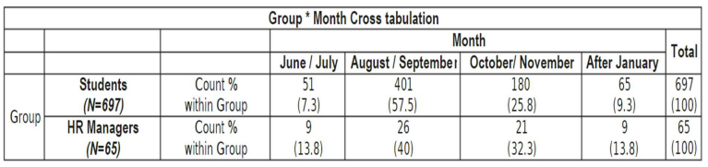

Table 1 shows that 57.5 per cent of the students feel that August and September as the ideal period and 25.8 per cent feel that October and November as ideal months for the campus placement process.

With respect to the HR managers, 40 per cent of them were of the opinion that August and September as the ideal months for the recruitment, where as 32.3 per cent of them stated the October – November.

**Table 4.2. Analysis of campus recruitment season – Chi square test**

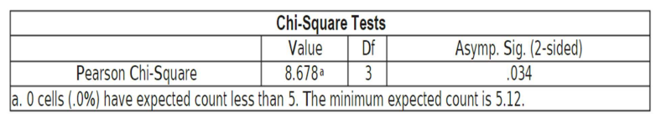

Here both the HR Managers and the students are not of the same opinion on the campus recruitment season, this is supported by the chi square tests (Value=8.678; Sig=0.034). Hence, hypothesis (H1) is not accepted.

**Table 3. Analysis of salary expectations – frequencies**

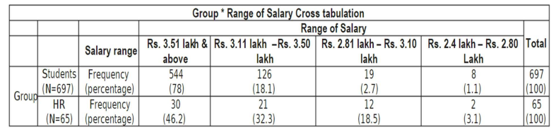

Table 3 shows the respondents expectations on entry level salary ranges. The software services companies in India have not increased the entry level salaries for more than 5 years.

The average salary per annum offered by the top 5 software services companies (Accenture, Cognizant, Infosys, TCS6 and Wipro) range between INR72.75 and INR 3.36 lakhs per annum for under graduate students and between INR 2.75 lakhs and INR 3.63 lakhs for post graduate students.

Core Engineering companies also have not increased the salary substantially. It ranged from INR 2.5 lakhs to 3.5 lakhs per annum 78 per cent of the students feel that the entry level salary should be INR 3.5 lakhs per annum. 46.2 per cent of the HR managers suggest that the entry salaries should be above INR 3.51 lakhs per annum.

**Table 4.4. Analysis of salary expectations - chi square test**

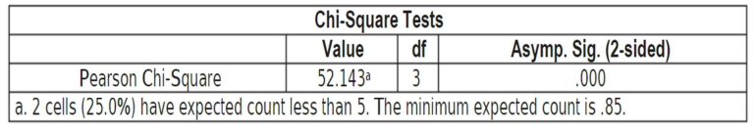

Chi square tests revealed (table 4.4) that there was significant difference (Value=52.43; Sig=0.000) in the perceptions of the two stake holders (HR managers and students) in terms of the salary expectations.

Hence, hypothesis (H2) is not accepted as there was no relationship in the opinion among the HR managers and students regarding the salary expectations. Analysis of salary expectations The Table 3 shows the perceptions of the students and HR managers on the perceptions of students and HR managers on compensation/salary to be offered to the campus recruits.

Tables 3 and 4 present the frequency and chi square test analysis on compensation component in campus recruitment.

**8 RESULT AND DISCUSSIONS**

**Result:**

**Admin** - The admin of the CRS put his credentials in the Login page. Admin can add the details of company and student. Admin can have whole access of the system.so that he can handle all the database and revert towards the query of the student and company.

**Student** -The student of the CRS put his credentials in the Login page. Student can generate the CV and can take the print of the CV. Student can view the company details. If student have any query regarding placement, he or she can ask the query through the chatbox.Students will get the noti cation of the events i.e. Campus placement or Seminars regarding placement,etc. held in the college.

**Company -** The company of the CRS put their credentials in the Login page.Company can view the CV's of the students and shortlist them for the interview.

**Discussion:**

* The student panel allowsthe studentsto create their pro les and upload all their details including their marks onto the system.
* The admin can check each student details and can remove faulty accounts.
* The system also consists of a company login where various companies visiting the college can view a list of students in that college and also their respective resumes.
* The software system allows students to view a list of companies who have posted for vacancy.
* The admin has overall rights over the system and can moderate and delete any details not pertaining to college placement rules.
* The system handles student as well as company data and e ciently displays all this data to respective sides.
* This system also contains forum page where many people could discuss or chat on multiple topics.

# OBJECTIVES

# The major objective of campus recruitment is to identify the talented and qualified students before they complete their education, as this process reduces the time for an industry to pick the candidates according to their need.

# ♣ To know about various companies using campus recruitment method and finding their strategies.

# ♣ To study the recent trends and challenges in campus recruitment method.

# 9. METHODOLOGY

The whole approach is depicted by the following flowchart.

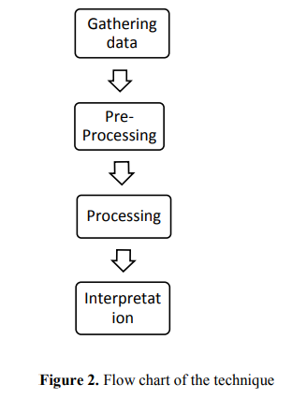

**9.1 Data gathering**

The sample data has been collected from our college placement department which consists of all the records of previous years students. The dataset collected consist of over 1000 instances of students.

**9.2 Pre processing**

Data pre processing is a technique that is used to convert raw data into a clean dataset. The data is gathered from different sources is in raw format which is not feasible for the analysis. Pre-processing for this approach takes 4 simple yet effective steps.

**9.2.1 Attribute selection**

Some of the attributes in the initial dataset that was not pertinent (relevant) to the experiment goal were ignored. The attributes name, roll no, credits, backlogs, whether placed or not, b.tech % ,gender are not used.

The main attributes used for this study are credit , backlogs , whether placed or not, b.tech %.

**9.2.2 Cleaning missing values**

In some cases, the dataset contains missing values. We need to be equipped to handle the problem when we come across them. Obviously, you could remove the entire line of data but what if you're inadvertently removing crucial information? after all we might not need to try to do that.

one in every of the foremost common plan to handle the matter is to require a mean of all the values of the same column and have it to replace the missing data. The library used for the task is called Scikit Learn preprocessing. It contains a class called Imputer which will help us take care of the missing data.

**9.2.3 Training and Test data**

Splitting the Dataset into Training set and Test Set Now the next step is to split our dataset into two. Training set and a Test set. We will train our machine learning models on our training set, i.e our machine learning models will try to understand any correlations in our training set and then we will test the models on our test set to examine how accurately it will predict.

A general rule of the thumb is to assign 80% of the dataset to training set and therefore the remaining 20% to test set.

**9.2.4 Feature Scaling**

The final step of data pre processing is feature scaling.

But what is it?

It is a method used to standardize the range of independent variables or features of data.

But why is it necessary?

A lot of machine learning models are based on Euclidean distance. If, for example, the values in one column (x) is much higher than the value in another column (y), (x2-x1) squared will give a far greater value than (y2-y1) squared.

So clearly, one square distinction dominates over the other square distinction. In the machine learning equations, the square difference with the lower value in comparison to the far greater value will almost be treated as if it does not exist. We do not want that to happen.

That is why it’s necessary to transform all our variables into the same scale. There are several ways of scaling the data. One way is called Standardization which may be used. For every observation of the selected column, our program will apply the formula of standardization and fit it to a scale.

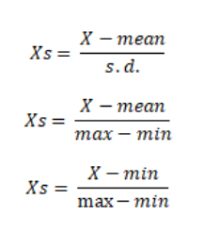

**9.3 Processing**

Processing in this paper's sense is applying different algorithms to the data to find the best results

**9.3.1 ID3 algorithm**

The decision tree technique involves constructing a tree to model the classification process. Once a tree is built, it is applied to each tuple in the database and results in classification for that tuple. The following issues are faced by most decision tree algorithms:

• Choosing splitting attributes

• Ordering of splitting attributes

• Number of splits to take

• Balance of tree structure and pruning

• Stopping criteria

The ID3 algorithm is a classification algorithm based on Information Entropy, its basic idea is that all examples are mapped to different categories according to different values of the condition attribute set; its core is to determine the best classification attribute form condition attribute sets. The algorithm chooses information gain as attribute selection criteria; usually the attribute that has the highest information gain is selected as the splitting attribute of current node, in order to make information entropy that the divided subsets need smallest . According to the different values of the attribute, branches can be established, each branch to create other nodes and branches until all the samples in a branch belong to the same category. To select the splitting attributes, the concepts of Entropy and Information Gain are used.

**A. Entropy**

Given probabilities p1, p2, …, ps, where ∑pi = 1, Entropy is defined as

H(p1, p2, …, ps) = ∑ - (pi log pi)

Entropy finds the amount of order in a given database state.

A value of H = 0 identifies a perfectly classified set. In other words, the higher the entropy, the higher the potential to improve the classification process.

**B. Information Gain**

ID3 chooses the splitting attribute with the highest gain in information, where gain is defined as difference between how much information is needed after the split. This is calculated by determining the differences between the entropies of the original dataset and the weighted sum of the entropies from each of the subdivided datasets. The formula used for this purpose is:

G(D, S) = H(D) - ∑P(Di)H(Di)

**9.3.2 Random forest**

The random forest algorithm can also be thought of as an ensemble method in machine learning. The input to a random forest algorithm is a dataset consisting of records, with attributes. Random subsets of the input are created.

On each of the random subset created, a decision tree will be constructed. The final class of a test record will be decided by the algorithm which uses the majority vote technique. The random forest algorithm makes use of the out of bag error technique.

Each tree is constructed using the following algorithm:

1. Let the number of training cases be N, and the number of variables in the classifier be M.

2. We are told the number m of input variables to be used to determine the decision at a node of the tree; m should be much less than M.

3. Choose a training set for this tree by selecting N times with replacement from all N available training cases (i.e. take a bootstrap sample). Use the rest of the cases to estimate the error of the tree, by predicting their classes.

4. For each node in the tree, randomly choose m variables on which to base the decision at that node. Calculate the best split based on these m variables in the training set.

5. Each tree is fully grown and not pruned (as may be done in constructing a normal tree classifier).

# 9.4 Random Forest Algorithm

Random Forest is a popular machine learning algorithm that belongs to the supervised learning technique. It can be used for both Classification and Regression problems in ML. It is based on the concept of **ensemble learning,** which is a process of combining multiple classifiers to solve a complex problem and to improve the performance of the model.

As the name suggests, **"Random Forest is a classifier that contains a number of decision trees on various subsets of the given dataset and takes the average to improve the predictive accuracy of that dataset."** Instead of relying on one decision tree, the random forest takes the prediction from each tree and based on the majority votes of predictions, and it predicts the final output.

**The greater number of trees in the forest leads to higher accuracy and prevents the problem of overfitting.**

The below diagram explains the working of the Random Forest algorithm:

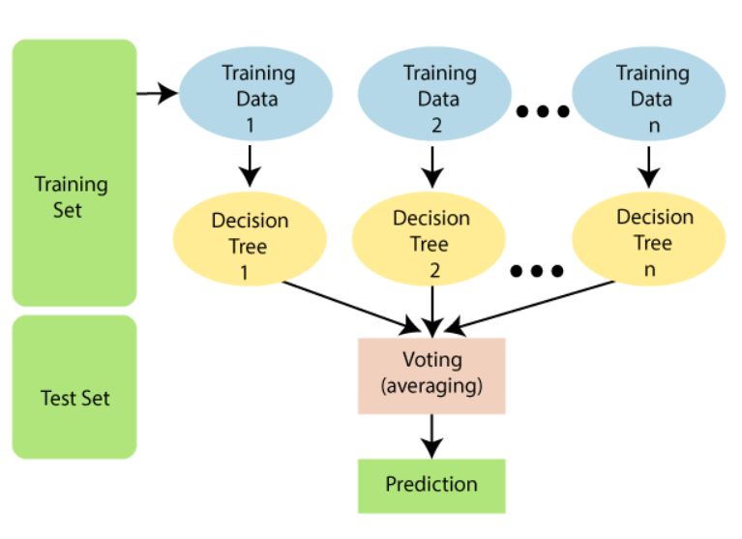

**9.4.1 ASSUMPTIONS FOR RANDOM FOREST**

Since the random forest combines multiple trees to predict the class of the dataset, it is possible that some decision trees may predict the correct output, while others may not. But together, all the trees predict the correct output. Therefore, below are two assumptions for a better Random forest classifier:

* There should be some actual values in the feature variable of the dataset so that the classifier can predict accurate results rather than a guessed result.
* The predictions from each tree must have very low correlations.

**9.4.2 WHY WE USE IT ?**

Below are some points that explain why we should use the Random Forest algorithm:

<="" li="">

* It takes less training time as compared to other algorithms.
* It predicts output with high accuracy, even for the large dataset it runs efficiently.
* It can also maintain accuracy when a large proportion of data is missing.

**9.4.3 HOW ITS ALGORITHM WORKS ?**

Random Forest works in two-phase first is to create the random forest by combining N decision tree, and second is to make predictions for each tree created in the first phase.

The Working process can be explained in the below steps and diagram:

**Step-1:** Select random K data points from the training set.

**Step-2:** Build the decision trees associated with the selected data points (Subsets).

**Step-3:** Choose the number N for decision trees that you want to build.

**Step-4:** Repeat Step 1 & 2.

**Step-5:** For new data points, find the predictions of each decision tree, and assign the new data points to the category that wins the majority votes.

The working of the algorithm can be better understood by the below example:

**Example:** Suppose there is a dataset that contains multiple fruit images. So, this dataset is given to the Random forest classifier. The dataset is divided into subsets and given to each decision tree. During the training phase, each decision tree produces a prediction result, and when a new data point occurs, then based on the majority of results, the Random Forest classifier predicts the final decision. Consider the below image:

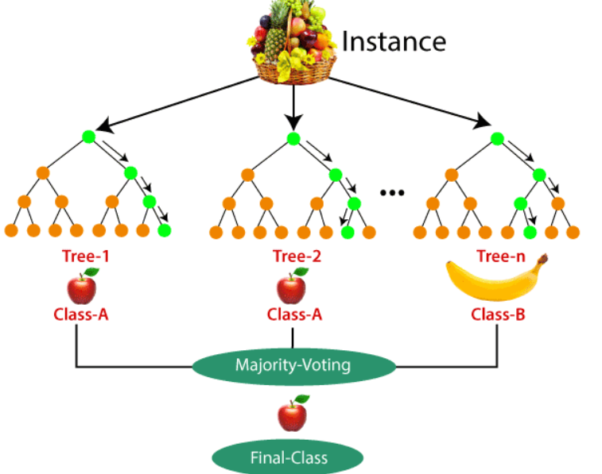

**9.5 APPLICATIONS OF RANDOM FOREST**

There are mainly four sectors where Random forest mostly used:

1. **Banking:** Banking sector mostly uses this algorithm for the identification of loan risk.
2. **Medicine:** With the help of this algorithm, disease trends and risks of the disease can be identified.
3. **Land Use:** We can identify the areas of similar land use by this algorithm.
4. **Marketing:** Marketing trends can be identified using this algorithm.

**9.5.1 ADVANTAGES OF RANDOM FOREST**

* Random Forest is capable of performing both Classification and Regression tasks.
* It is capable of handling large datasets with high dimensionality.
* It enhances the accuracy of the model and prevents the overfitting issue.

**9.5.2 DISADVANTAGES OF RANDOM FOREST**

* Although random forest can be used for both classification and regression tasks, it is not more suitable for Regression tasks.

**10 PROCEDURE**

One of the best ways you can prepare for a campus placement is by knowing about the complete procedure. This way, you can prepare for all the steps involved and feel more confident on the day of campus placement or recruitment interviews.

**Here is the most common procedure for campus placement.**

### ****1. Pre-Placement Presentation****

This is the first part of the procedure. In the pre-placement presentation, the companies that have come for the campus placements put up presentations regarding their organisation. You get to know all about the companies, their recruitment process and the salaries you can expect. After the presentations, students are allowed to ask questions to the representatives.

### ****2. Qualifications****

In this step, you will know about the qualifications and other important criteria companies have set for recruitment. Usually, companies interview only those candidates that belong to a certain stream of education and will choose from among them. Since colleges teach multiple disciplines, and placements drives for all disciplines are held together, make sure you know which companies are interested in your education.

### ****3. Written Examination****

Once you know the companies you are going to be applying for, you will have to attempt an aptitude test. The test may vary based on the positions you are applying for, but there are a few tests specific to education streams. For example, during engineering placement drives, the Wheebox Graduate Employability Test is the standard test that most companies use.

This exam tests coding skills, math skills, English language skills, and critical thinking skills. Similarly, there are other tests for other disciplines.

### ****4. Group Discussion****

A few times, this round is not conducted, but many companies use this for filtering candidates. A group of students is created that is moderated by a judge. A common topic is given for the group to discuss. Once the discussions begin, students are judged on their knowledge, their communication skills, their confidence, their leadership skills, and their listening and retaining capabilities. In the GD round, the latest news and current affairs are discussed, so you need to brush up on your knowledge.

### ****5.Technical Knowledge Interview****

This is an interview that will check your knowledge related to the subject you are studying, and other important technical knowledge that will be related to your profession. This round is mostly conducted in a one-on-one setting, but if there are many students and interviews are short on time, they may conduct interviews as a group.

### ****6. Formal Interview****

This is the final part of the procedure – formal interview. In this round, you are judged for your confidence and abilities. You can even term this interview as your job interview. If you have done internships, or have worked on real industry projects, it will really help you do well during this interview. In this interview, you will most likely know if you have been selected.

### ****7. Post Placement Discussion****

If you have cleared the formal interview, you will get an offer letter and a post-placement discussion. You will be given guidelines and be told about the joining procedure. You will also be told any other important information you need to know.

**11 CONCLUSIONS**

From a proper analysis of positive points and constraints on the CRS, it can be safely concluded that the project CRS is a highly e cient GUI-based component. This application is working properly and meeting user requirements. This component can be easily plugged into many other systems.

Nowadays the manual process of searching for a job of one's choice as well as searching for the appropriate candidate for a specific job has become a huge task and so realizing the need for easy management of this process, the site has been developed.

It is very easy to update and maintain information through this site. The main features of this site include flexibility, ease of manipulation of information, easy access searching, storage, reduction of manual work in an e cient manner, a quick, convenient, reliable, timely and search and employment professionals worldwide and it is also very economical.

The project could very well be enhanced further as per the requirements.In the existing Placement system, maximum work goes manually and it takes time for any changes in the system. Proposed system gets automated in the online registration all the user, activation of the user and deactivation of the user, personalization to the user, resources to be provided online, communication between the users, and gives online feedback.

The admin can see the user information and will validate it, generate the student list on the basis of company criteria; company details can be provided to the user, searching and sorting can be done, and reports to be generated.

Increasing need of comfort and inculcating all the data at one place has always been a challenging process for everybody. With the introduction of this web based training and placement portal we promise to make the lives of students and administration a little easier by proposing an alternative for the current system being used. Easy accessibility and functioning of this portal will allow easy management of the allocation process during placement period.

With the increasing demand of digitalization in every aspect of day to day activities we can anticipate the great demand for such portals in the near future and the comfort it will bring with it to the lives of all. Also the rapidly increasing concerns of global warming due to increase deforestation for large amount of paper that it requires we here have a minor role to save Mother Nature. So we hope all of you can sit back and relax and enjoy the luxury of Digitalization. More so in this busy and exhausting life we are saving one of the most crucial factor that keeps us running that is human energy.

**12 FUTURE SCOPE**

This system is helpful for the college campus recruitment process for the training and placement department to shortlist students in advance and prepares students for placements. The system will be helpful for the students to get a rough idea about their CVs.

Goals:

• Reduced entry work.

• Easy retrieval of information

• Reduced errors due to human intervention

• User-friendly screens to enter the data

• Portable and flexible for further enhancement

• Web-enabled.

• Fast sending of information requested

This system has a big scope to do. Students can maintain their information. Notifications are sent to students email address about the companies. Students can access previous information about recruitment. This project has a large scope as it has the following features which help in making it easy to use, understand and modify it:

• Automation of Placement Procedure

• No Need to do Paper Work

• To save the environment by using paper free work

**REFERENCES**

[1] NileshRathod, Seema Shah, KavitaShirsat,”An Interactive Online Training & Placement System”, International Journal of Advanced Research in Computer and Communication Engineering, Vol. 3, Issue 12,December-2013.

[2] Mr. R. J. laird, Dr. C. R. turner mima,” Interactive Web based Placement Management – Principles and Practice using OPUS” CGU-WACE, 2008.

[3] Hitesh Kasture, SumitSaraiyya, AbhishekMalviya, PreetiBhagat,“Training & Placement Web Portal”, International Journal on Recent and Innovation Trends in Computing and Communication ISSN: 2321- 8169 Volume: 2 Issue: 3,March-2014.

[4] Prof. AnaghaKulkarni , PriyankaHajare, PriyankaKhandave , ShitalAdhav,SwatiPimpale,“ Implementation of Online Placement System”, IJERMT All Rights Reserved International Journal of Emerging Research in Management &Technology ISSN: 2278 -9359 (Volume-5, Issue-1), January2016.

[5] Mr R J LAIRD,“ Interactive Web-based Placement Management–Principles and Practice using OPUS”, School of Engineering, University of Ulster, Shore Road, NEWTOWNABBEY, Co. Antrim, UK, BT37 0QB, 2008.

[6] Swati Choudhary, Monica Landge, ShitalSalunke, SwarupataSutar, KirtiMhamunkar-“Advance Training and placement web portal” International Journal of Technical Research and Application ISSN: 2320- 8163 Volume:4 Issue: 2,March-April 2016.